Contents
What is Web Services 3
Why you need to learn web services 3
*Reuse already developed (old) functionality into new software: 3
Usability: 3
*Interoperability: 4
*Loosely Coupled: 4
*Ease of Integration: 4
Deployability: 4
Some jargons used in Web services: 4
Simple Object Access Protocol (SOAP): 4
Web Service Description Language (WSDL): 4
Universal Description, Discovery and Integration (UDDI): 7
Web service design approaches: 7
Contract last or Bottom up approach: 7
Contract first or top Down Approach: 7
SOAP web service Introduction 7
Restful web service introduction 9
HTTP Methods: 11
Features of Restful web services: 11
SOAP and REST Web Service Using CXF 12
Add the following entries in web.xml 12
Add the following entries in Pom.xml 12
Define the Pojo 17
Employee.java 17
Empaddress.java 19
Customer.java 20
Address.java 22
Define the interfaces & Implementation classes 23
Restful Interface 23
Restful interface implementation 25
SOAP interface 29
SOAP Implementation class 30
ApplicationContext.xml (where spring beans and jax-ws and jax-rs services were configured) 33
RestfulWSClient.java 35
Difference between SOAP and Restful Web services 37
Java Web Service Client without tool 41
Java Web Service Client via wsimport tool 41
Java Web Service Client via wsgen tool 41
How to trace SOAP message in Eclipse IDE 42
JAX-WS Handler 45
JAX-WS : SOAP handler in server side 45
JAX-WS: SOAP handler in client side 51
JAX-WS : SOAP handler testing for client and server side 56
JAX-WS Integration 58
JAX-WS + Java Web Application Integration Example 58
JAX-WS + Spring integration example 61
JAX-WS Security in Tomcat 66
Deploy JAX-WS web services on Tomcat + SSL connection 66
Application Authentication with JAX-WS 68
Authentication with JAX-WS Example 69
Container Authentication with JAX-WS – (Tomcat version) 72
How to configure Tomcat to support SSL or https 77
How to bypass certificate checking in a Java web service client 79
java.security.cert.CertificateException: No name matching localhost found 82
Web services Handler Chains 84
Similarities between Handlers and CXF Interceptors 87
Apache CXF Interceptors 88
Adding Interceptors to your Web services 93
Adding Fault Interceptors to your Web services 94
CXF contributed interceptors 95
Default JAX-WS Incoming interceptor chain (Server): 95
Default Outgoing chain stack (Server): 96

What is Web Services

Web service is a way of communication that allows interoperability between different applications on different platforms, for example, a java based application on Windows can communicate with a .Net based one on Linux. The communication can be done through a set of XML messages over HTTP protocol.
Web services are browsers and operating system independent service, which means it can run on any browser without the need of making any changes. Web Services take Web-applications to the Next Level

Types of web services

- JAX-WS (Java API for XML Web services)
- JAX-RS (Java API for Restful web services)
- JAX-RPC (Java API for Remote Procedure call)

Why you need to learn web services

*Reuse already developed (old) functionality into new software:
Let’s understand with very simple example. Let’s say you are developing a finance software for a company on java and you have old .net software which manages salary of employees. So rather then developing new software for employee part, you can use old software and for other parts like infrastructure you can develop your own functionalities.

Usability:
Web Services allow the business logic of many different systems to be exposed over the Web. This gives your applications the freedom to choose the Web Services that they need. Instead of re-inventing the wheel for each client, you need only include additional application-specific business logic on the client-side. This allows you to develop services and/or client-side code using the languages and tools that you want.

*Interoperability:
This is the most important benefit of Web Services. Web Services typically work outside of private networks, offering developers a non-proprietary route to their solutions. Web Services also let developers use their preferred programming languages. In addition, thanks to the use of standards-based communications methods, Web Services are virtually platform-independent.

*Loosely Coupled:
Each service exists independently of the other services that make up the application. Individual pieces of the application to be modified without impacting unrelated areas.

*Ease of Integration:
Data is isolated between applications creating ’silos’. Web Services act as glue between these and enable easier communications within and across organizations.

Deployability:
Web Services are deployed over standard Internet technologies. This makes it possible to deploy Web Services even over the fire wall to servers running on the Internet on the other side of the globe. Also thanks to the use of proven community standards, underlying security (such as SSL) is already built-in.

Some jargons used in Web services:

Simple Object Access Protocol (SOAP):
SOAP is a protocol specification for exchanging structured information in the implementation of Web services in computer networks. It relies on XML as its message format.

Web Service Description Language (WSDL):
WSDL stands for Web Service Description Language. It is an XML file that describes
the technical details of how to implement a web service, more specifically the URI,
port, method names, arguments, and data types. Since WSDL is XML, it is both
human-readable and machine-consumable, which aids in the ability to call and bind to
services dynamically.
Elements of WSDL are:
definitions
It is the root element of a WSDL 2.0 file. It usually contains a set of name space declarations which are used throughout the WSDL file.
Types
The WSDL types element describes the data types used by your web service. Data types are usually specified by XML schema. It can be described in any language as long as your web services API supports it.
Binding
The WSDL binding element describes how your web service is bound to a protocol. In other words, how your web service is accessible. To be accessible, the web service must be reachable using some network protocol. This is called "binding" the web service to the protocol.
The binding element describes how the web service is accessed over the network. Typically the binding element binds the web service to the HTTP protocol.
PortType
The WSDL interface element describes the operations supported by your web service. It is similar to methods in programming language. Client can only call one operation per request.
Service
The service element describes where the web service can be accessed on the network. Typically the service element contains a URL to the service.
Endpoint
The endpoint element describes the address of the web service. The endpoint binding attribute describes what binding element this endpoint uses.i.e. Protocol with which you will access web service. The address attribute describes the URI at which you can access the service.
Message
The message element describes the data being exchanged between the Web service providers and consumers.
Sample wsdl
<?xml version="1.0" encoding="UTF-8"?>
<wsdl:definitions targetNamespace="http://webservices.javapostsforlearning.arpit.org" xmlns:apachesoap="http://xml.apache.org/xml-soap" xmlns:impl="http://webservices.javapostsforlearning.arpit.org" xmlns:intf="http://webservices.javapostsforlearning.arpit.org" xmlns:wsdl="http://schemas.xmlsoap.org/wsdl/" xmlns:wsdlsoap="http://schemas.xmlsoap.org/wsdl/soap/" xmlns:xsd="http://www.w3.org/2001/XMLSchema">
<!--WSDL created by Apache Axis version: 1.4
Built on Apr 22, 2006 (06:55:48 PDT)-->

<wsdl:types>
<schema elementFormDefault="qualified" targetNamespace="http://webservices.javapostsforlearning.arpit.org" xmlns="http://www.w3.org/2001/XMLSchema">
<element name="sayHelloWorld">
<complexType>
<sequence>
<element name="name" type="xsd:string"/>
</sequence>
</complexType>
</element>
<element name="sayHelloWorldResponse">
<complexType>
<sequence>
<element name="sayHelloWorldReturn" type="xsd:string"/>
</sequence>
</complexType>
</element>
</schema>
</wsdl:types>

<wsdl:message name="sayHelloWorldRequest">
<wsdl:part element="impl:sayHelloWorld" name="parameters"/>
</wsdl:message>
<wsdl:message name="sayHelloWorldResponse">
<wsdl:part element="impl:sayHelloWorldResponse" name="parameters"/>
</wsdl:message>

<wsdl:portType name="HelloWorld">
<wsdl:operation name="sayHelloWorld">
<wsdl:input message="impl:sayHelloWorldRequest" name="sayHelloWorldRequest"/>
<wsdl:output message="impl:sayHelloWorldResponse" name="sayHelloWorldResponse"/>
</wsdl:operation>
</wsdl:portType>

<wsdl:binding name="HelloWorldSoapBinding" type="impl:HelloWorld">
<wsdlsoap:binding style="document" transport="http://schemas.xmlsoap.org/soap/http"/>
<wsdl:operation name="sayHelloWorld">
<wsdlsoap:operation soapAction=""/>
<wsdl:input name="sayHelloWorldRequest">
<wsdlsoap:body use="literal"/>
</wsdl:input>
<wsdl:output name="sayHelloWorldResponse">
<wsdlsoap:body use="literal"/>
</wsdl:output>
</wsdl:operation>
</wsdl:binding>

<wsdl:service name="HelloWorldService">
<wsdl:port binding="impl:HelloWorldSoapBinding" name="HelloWorld">
<wsdlsoap:address location="http://localhost:8080/SimpleSOAPExample/services/HelloWorld"/>
</wsdl:port>
</wsdl:service>

</wsdl:definitions>

Relationship

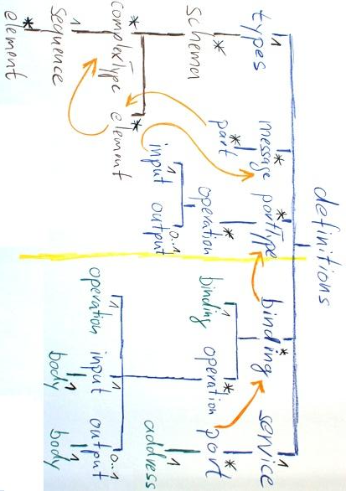
Universal Description, Discovery and Integration (UDDI):
UDDI stands for Universal Description, Discovery and Integration. It is a directory service.
Web services can register with a UDDI and make themselves available through it for discovery

Web service design approaches:

Contract last or Bottom up approach:
When using contract last approach, you first write your java code then you creates web service contract (WSDL) .There are various kinds of tools which can generate WSDL on the basis of java code.

Contract first or top Down Approach:
It is reverse of contract first. Here you first define web service contract. You define all the elements of WSDL first then after that you create your java logic.

SOAP web service Introduction
Simple Object Access Protocol (SOAP) is a standard protocol specification for message exchange based on XML. Communication between the web service and client happens using XML messages.
A simple web service architecture have two components
- Client
- Service provider
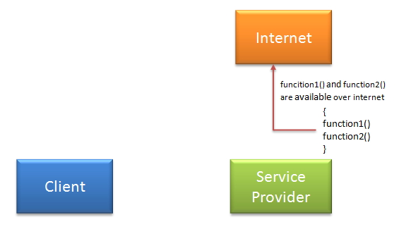
So as in above diagram, how client will communicate to service provider. So in order to communicate client must know some information for e.g.
- Location of web services server
- Functions available, signature and return types of function.
- Communication protocol
- Input output formats
Service provider will create a standard XML file which will have all above information. So If this file is given to client then client will be able to access web service. This XML file is called WSDL.

What is WSDL?
WSDL stands for Web Service Description Language. It is an XML file that describes
the technical details of how to implement a web service, more specifically the URI,
port, method names, arguments, and data types. Since WSDL is XML, it is both
human-readable and machine-consumable, which aids in the ability to call and bind to
services dynamically. Using this WSDL file we can understand things like,
- Port / Endpoint – URL of the web service
- Input message format
- Output message format
- Security protocol that needs to be followed
- Which protocol the web service uses

Ways to access web service:
There are two ways to access web service.
- If Service provider knows client: If service provider knows its client then it will provide its wsdl to client and client will be able to access web service.
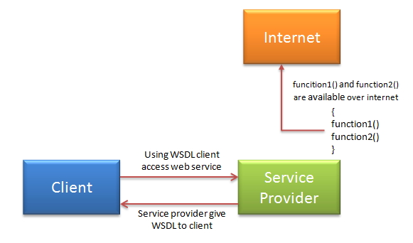
• Service provider register its WSDL to UDDI and client can access it from UDDI: UDDI stands for Universal Description, Discovery and Integration. It is a directory service. Web services can register with a UDDI and make themselves available through it for discovery. So following steps are involved.
- Service provider registers with UDDI.
- Client searches for service in UDDI.
- UDDI returns all service providers offering that service.
- Client chooses service provider
- UDDI returns WSDL of chosen service provider.
- Using WSDL of service provider, client accesses web service.
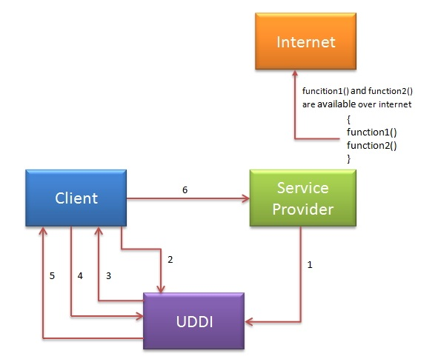

Restful web service introduction

REST is an architectural style which was brought in by Roy Fielding in 2000
In the web services terms, Representational State Transfer (REST) is a stateless client-server architecture in which the web services are viewed as resources and can be identified by their URIs. Web service clients that want to use these resources access via globally defined set of remote methods that describe the action to be performed on the resource.
It consists of two components

- REST server which provides access to the resources and
- REST client which accesses and modify the REST resources.
In the REST architecture style, clients and servers exchange representations of resources by using a standardized interface and protocol. REST isn't protocol specific, but when people talk about REST they usually mean REST over HTTP.
The response from server is considered as the representation of the resources. This representation can be generated from one resource or more number of resources.

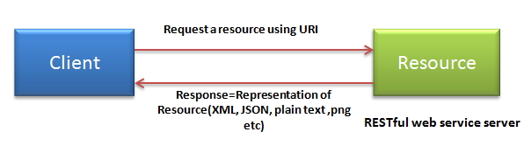
REST allows that resources have different representations, e.g. xml, json etc. The rest client can ask for specific representation via the HTTP protocol.

HTTP Methods:
Restful web services use HTTP protocol methods for the operations they perform. Methods are:
- GET: It defines a reading access of the resource without side-effects. This operation is idempotent i.e. they can be applied multiple times without changing the result
- PUT: It creates a new resource. It must also be idempotent.
- DELETE: It removes the resources. The operations are idempotent i.e. they can get repeated without leading to different results.
- POST: It updates an existing resource or creates a new resource.

Features of Restful web services:
Resource identification through URI: Resources are identified by their URIs (typically links on internet). So, a client can directly access a RESTful Web Services using the URIs of the resources (same as you put a website address in the browser’s address bar and get some representation as response).
Uniform interface: Resources are manipulated using a fixed set of four create, read, update, delete operations: PUT, GET, POST, and DELETE.
Client-Server: A clear separation concerns is the reason behind this constraint. Separating concerns between the Client and Server helps improve portability in the Client and Scalability of the server components.
Stateless: each request from client to server must contain all the information necessary to understand the request, and cannot take advantage of any stored context on the server.
Cache: to improve network efficiency responses must be capable of being labeled as cacheable or non-cacheable.
Named resources - the system is comprised of resources which are named using a URL.
Interconnected resource representations - the representations of the resources are interconnected using URLs, thereby enabling a client to progress from one state to another.
Layered components - intermediaries, such as proxy servers, cache servers, gateways, etc, can be inserted between clients and resources to support performance, security, etc.
Self-descriptive messages: Resources are decoupled from their representation so that their content can be accessed in a variety of formats, such as HTML, XML, plain text, PDF, JPEG, JSON, and others.

SOAP and REST Web Service Using CXF

Add the following entries in web.xml
<?xml version="1.0"?>
<!DOCTYPE web-app PUBLIC "-//Sun Microsystems, Inc.//DTD Web Application 2.3//EN"
"http://java.sun.com/dtd/web-app_2_3.dtd">

<web-app>
<display-name>RestWithCXF</display-name>

<context-param>
<param-name>contextConfigLocation</param-name>
<param-value>classpath:com/javatch/rest/cxf.xml</param-value>
</context-param>

<listener>
<listener-class>
org.springframework.web.context.ContextLoaderListener
</listener-class>
</listener>

<servlet>
<servlet-name>CXFServlet</servlet-name>
<servlet-class>
org.apache.cxf.transport.servlet.CXFServlet
</servlet-class>
</servlet>

<servlet-mapping>
<servlet-name>CXFServlet</servlet-name>
<url-pattern>/services/*</url-pattern>
</servlet-mapping>

</web-app>

Add the following entries in Pom.xml
<project xmlns="http://maven.apache.org/POM/4.0.0" xmlns:xsi="http://www.w3.org/2001/XMLSchema-instance"
xsi:schemaLocation="http://maven.apache.org/POM/4.0.0 http://maven.apache.org/maven-v4_0_0.xsd">
<modelVersion>4.0.0</modelVersion>
<groupId>com.helpezee.service</groupId>
<artifactId>MavenWSCXF</artifactId>
<packaging>war</packaging>
<version>0.0.1-SNAPSHOT</version>
<name>MavenWSCXF Maven Webapp</name>
<url>http://maven.apache.org</url>
<build>
<finalName>MavenWSCXF</finalName>
<!-- Plugin for compiling the sources -->
<plugins>
<plugin>
<groupId>org.apache.maven.plugins</groupId>
<artifactId>maven-compiler-plugin</artifactId>
<version>3.0</version>
<configuration>
<source>1.6</source>
<target>1.6</target>
</configuration>
</plugin>
</plugins>
</build>
<!--
<properties>
<spring.version>3.0.5.RELEASE</spring.version>
<junit.version>4.11</junit.version>
<jdk.version>1.6</jdk.version>
</properties>
-->
<dependencies>
<dependency>
<groupId>junit</groupId>
<artifactId>junit</artifactId>
<version>3.8.1</version>
<scope>test</scope>
</dependency>

<dependency>
<groupId>log4j</groupId>
<artifactId>log4j</artifactId>
<version>1.2.16</version>
<scope>compile</scope>
</dependency>
<dependency>
<groupId>org.codehaus.jackson</groupId>
<artifactId>jackson-jaxrs</artifactId>
<version>1.8.2</version>
<type>jar</type>
<scope>compile</scope>
</dependency>

<dependency>
<groupId>org.codehaus.jackson</groupId>
<artifactId>jackson-xc</artifactId>
<version>1.8.2</version>
<type>jar</type>
<scope>compile</scope>
</dependency>

<dependency>
<groupId>javax.xml.ws</groupId>
<artifactId>jaxws-api</artifactId>
<version>2.2.8</version>
<type>jar</type>
<scope>test</scope>
</dependency>

<dependency>
<groupId>javax.servlet</groupId>
<artifactId>servlet-api</artifactId>
<version>2.5</version>
<type>jar</type>
<scope>compile</scope>
</dependency>

<!-- Spring Dependencies -->
<dependency>
<groupId>org.springframework</groupId>
<artifactId>spring-web</artifactId>
<version>3.0.5.RELEASE</version>
<type>jar</type>
<scope>compile</scope>
</dependency>

<dependency>
<groupId>org.springframework</groupId>
<artifactId>spring-core</artifactId>
<version>3.0.5.RELEASE</version>
<type>jar</type>
<scope>compile</scope>
</dependency>

<!-- CXF Dependencies -->
<dependency>
<groupId>org.apache.cxf</groupId>
<artifactId>cxf-rt-frontend-jaxrs</artifactId>
<version>2.2.6</version>
<scope>compile</scope>
</dependency>

<dependency>
<groupId>org.apache.cxf</groupId>
<artifactId>cxf-rt-frontend-jaxws</artifactId>
<version>2.2.6</version>
<type>jar</type>
<scope>compile</scope>
</dependency>

<dependency>
<groupId>org.apache.cxf</groupId>
<artifactId>cxf-rt-ws-policy</artifactId>
<version>2.2.6</version>
<type>jar</type>
<scope>compile</scope>
</dependency>

<dependency>
<groupId>org.apache.cxf</groupId>
<artifactId>cxf-rt-bindings-http</artifactId>
<version>2.2.6</version>
<type>jar</type>
<scope>compile</scope>
</dependency>

<dependency>
<groupId>org.apache.cxf</groupId>
<artifactId>cxf-rt-transports-http</artifactId>
<exclusions>
<exclusion>
<artifactId>org.springframework</artifactId>
<groupId>spring-core</groupId>
</exclusion>
<exclusion>
<artifactId>org.springframework</artifactId>
<groupId>spring-beans</groupId>
</exclusion>
<exclusion>
<artifactId>org.springframework</artifactId>
<groupId>spring-context</groupId>
</exclusion>
<exclusion>
<artifactId>commons-lang</artifactId>
<groupId>commons-lang</groupId>
</exclusion>
<exclusion>
<groupId>com.sun.xml.bind</groupId>
<artifactId>jaxb-impl</artifactId>
</exclusion>
<exclusion>
<groupId>javax.xml.bind</groupId>
<artifactId>jaxb-api</artifactId>
</exclusion>
<exclusion>
<artifactId>geronimo-activation_1.1_spec</artifactId>
<groupId>org.apache.geronimo.specs</groupId>
</exclusion>
<exclusion>
<artifactId>geronimo-stax-api_1.0_spec</artifactId>
<groupId>org.apache.geronimo.specs</groupId>
</exclusion>
<exclusion>
<artifactId>geronimo-annotation_1.0_spec</artifactId>
<groupId>org.apache.geronimo.specs</groupId>
</exclusion>
<exclusion>
<artifactId>geronimo-javamail_1.4_spec</artifactId>
<groupId>org.apache.geronimo.specs</groupId>
</exclusion>
</exclusions>
<version>2.2.6</version>
<type>jar</type>
<scope>compile</scope>
</dependency>
</dependencies>
</project>

Define the Pojo

Employee.java

package com.helpezee.dto.employee;
import javax.xml.bind.annotation.XmlAccessType;
import javax.xml.bind.annotation.XmlAccessorType;
import javax.xml.bind.annotation.XmlElement;
import javax.xml.bind.annotation.XmlRootElement;
import javax.xml.bind.annotation.XmlType;
@XmlRootElement(name="employee")
@XmlAccessorType(XmlAccessType.FIELD)
@XmlType(name = "employee", propOrder = {
"empaddress",
"customerId",
"customerName",
"phone"
})
public class Employee {
@XmlElement(required = true)
protected Empaddress empaddress;
protected long customerId;
protected String customerName;
protected String phone;
public Empaddress getEmpaddress() {
return empaddress;
}
public void setEmpaddress(Empaddress value) {
this.empaddress = value;
}
public long getCustomerId() {
return customerId;
}
public void setCustomerId(long value) {
this.customerId = value;
}
public String getCustomerName() {
return customerName;
}
public void setCustomerName(String value) {
this.customerName = value;
}
public String getPhone() {
return phone;
}
public void setPhone(String value) {
this.phone = value;
}
}

Empaddress.java

package com.helpezee.dto.employee;
import javax.xml.bind.annotation.XmlAccessType;
import javax.xml.bind.annotation.XmlAccessorType;
import javax.xml.bind.annotation.XmlRootElement;
import javax.xml.bind.annotation.XmlType;
@XmlRootElement(name="empaddress")
@XmlAccessorType(XmlAccessType.FIELD)
@XmlType(name = "empaddress", propOrder = {
"street",
"city",
"state",
"country",
"pincode"
})
public class Empaddress {
protected String street;
protected String city;
protected String state;
protected String country;
protected String pincode;
public String getStreet() {
return street;
}
public void setStreet(String value) {
this.street = value;
}
public String getCity() {
return city;
}
public void setCity(String value) {
this.city = value;
}
public String getState() {
return state;
}
public void setState(String value) {
this.state = value;
}
public String getCountry() {
return country;
}
public void setCountry(String value) {
this.country = value;
}
public String getPincode() {
return pincode;
}
public void setPincode(String value) {
this.pincode = value;
}
}

Customer.java
package com.helpezee.dto.customer;
import javax.xml.bind.annotation.XmlAccessType;
import javax.xml.bind.annotation.XmlAccessorType;
import javax.xml.bind.annotation.XmlElement;
import javax.xml.bind.annotation.XmlRootElement;
import javax.xml.bind.annotation.XmlType;
@XmlRootElement(name="customer")
@XmlAccessorType(XmlAccessType.FIELD)
@XmlType(name = "customer", propOrder = {
"address",
"customerId",
"customerName",
"phone"
})
public class Customer {
@XmlElement(required = true)
protected Address address;
protected long customerId;
@XmlElement(required = true)
protected String customerName;
protected long phone;
public Address getAddress() {
return address;
}
public void setAddress(Address value) {
this.address = value;
}
public long getCustomerId() {
return customerId;
}
public void setCustomerId(long value) {
this.customerId = value;
}
public String getCustomerName() {
return customerName;
}
public void setCustomerName(String value) {
this.customerName = value;
}
public long getPhone() {
return phone;
}
public void setPhone(long value) {
this.phone = value;
}
}

Address.java
package com.helpezee.dto.customer;
import javax.xml.bind.annotation.XmlAccessType;
import javax.xml.bind.annotation.XmlAccessorType;
import javax.xml.bind.annotation.XmlElement;
import javax.xml.bind.annotation.XmlRootElement;
import javax.xml.bind.annotation.XmlType;
@XmlRootElement(name="address")
@XmlAccessorType(XmlAccessType.FIELD)
@XmlType(name = "address", propOrder = {
"street",
"city",
"state",
"country",
"pincode"
})
public class Address {
@XmlElement(required = true)
protected String street;
@XmlElement(required = true)
protected String city;
@XmlElement(required = true)
protected String state;
@XmlElement(required = true)
protected String country;
protected long pincode;
public String getStreet() {
return street;
}
public void setStreet(String value) {
this.street = value;
}
public String getCity() {
return city;
}
public void setCity(String value) {
this.city = value;
}
public String getState() {
return state;
}
public void setState(String value) {
this.state = value;
}
public String getCountry() {
return country;
}
public void setCountry(String value) {
this.country = value;
}
public long getPincode() {
return pincode;
}
public void setPincode(long value) {
this.pincode = value;
}
}

Define the interfaces & Implementation classes

Restful Interface
import javax.jws.WebService;
import javax.jws.soap.SOAPBinding;
import javax.ws.rs.Consumes;
import javax.ws.rs.DELETE;
import javax.ws.rs.GET;
import javax.ws.rs.HeaderParam;
import javax.ws.rs.POST;
import javax.ws.rs.PUT;
import javax.ws.rs.Path;
import javax.ws.rs.PathParam;
import javax.ws.rs.Produces;
import javax.ws.rs.QueryParam;
import javax.ws.rs.core.Response;
import com.helpezee.dto.customer.Customer;
@Path("/")
@WebService(targetNamespace = "http://ws.helpezee.com/services/cxf", endpointInterface = "http:helpezee.wordpress.com/rest")
@SOAPBinding(parameterStyle = SOAPBinding.ParameterStyle.BARE)
public interface DemoCustomerService {

// RESTFUL Interfaces

@GET
@Path("/getCustomerByIdPath/{custId}")
@Produces({ "application/xml", "application/json" })
@Consumes({ "application/xml", "application/json" })
public Response getCustomerByIdPath(@PathParam("custId") long custId);

@GET
@Path("/getCustomerByIdHead")
@Produces({ "application/xml", "application/json" })
@Consumes({ "application/xml", "application/json" })
public Response getCustomerByIdHead(
@HeaderParam(value = "custId") long custId);

@GET
@Path("/getCustomerByIdQuery")
@Produces({ "application/xml", "application/json" })
@Consumes({ "application/xml", "application/json" })
public Response getCustomerByIdQuery(@QueryParam("custId") long custId);

@POST
@Path("/addCustomer")
@Produces({ "application/xml", "application/json" })
@Consumes({ "application/xml", "application/json" })
public Response addCustomer(Customer customer);
@DELETE
@Path("/deleteCustomer")
@Produces({ "application/xml", "application/json" })
@Consumes({ "application/xml", "application/json" })
public Response deleteCustomer(@QueryParam("custId") long custId);
@PUT
@Path("/updateCustomer")
@Produces({ "application/xml", "application/json" })
@Consumes({ "application/xml", "application/json" })
public Response updateCustomer(Customer customer);
}

Restful interface implementation

import java.util.HashMap;
import java.util.Map;
import javax.ws.rs.core.Context;
import javax.ws.rs.core.Response;
import javax.ws.rs.core.UriInfo;
import org.apache.log4j.Logger;
import com.helpezee.dto.customer.Address;
import com.helpezee.dto.customer.Customer;
public class DemoCustomerServiceImpl implements DemoCustomerService {
@Context
UriInfo uriInfo;
private final static String ACCESS_CONTROL_ALLOW_ORIGIN = "*";
private Logger log;
private Map<Long, Customer> customers;

public DemoCustomerServiceImpl() {
log = Logger.getLogger(DemoCustomerServiceImpl.class);
customers = new HashMap<Long, Customer>();
}
public Response getCustomerByIdPath(long custId) { //using path param
log.info("Executing getCustomerByIdPath operation");
System.out.println("Executing getCustomerByIdPath operation");
if (!customers.containsKey(custId)) {
return Response.status(Response.Status.BAD_REQUEST)
.location(uriInfo.getAbsolutePath())
.entity("customer not found")
.header("Access-Control-Allow-Origin", ACCESS_CONTROL_ALLOW_ORIGIN)
.build();
}
return Response.ok(uriInfo.getAbsolutePath())
.entity(customers.get(custId))
.header("Access-Control-Allow-Origin", ACCESS_CONTROL_ALLOW_ORIGIN)
.build();
}

public Response getCustomerByIdHead(long custId) { //using HeaParam
log.info("Executing getCustomerByIdHead operation");
System.out.println("Executing getCustomerByIdHead operation");
if (!customers.containsKey(custId)) {
return Response.status(Response.Status.BAD_REQUEST)
.location(uriInfo.getAbsolutePath())
.entity("customer not found")
.header("Access-Control-Allow-Origin", ACCESS_CONTROL_ALLOW_ORIGIN)
.build();
}
return Response.ok(uriInfo.getAbsolutePath())
.entity(customers.get(custId))
.header("Access-Control-Allow-Origin", ACCESS_CONTROL_ALLOW_ORIGIN)
.build();
}

public Response getCustomerByIdQuery(long custId) { //Using QueryParam
log.info("Executing getCustomerByIdQuery operation");
System.out.println("Executing getCustomerByIdQuery operation");
if (!customers.containsKey(custId)) {
return Response.status(Response.Status.BAD_REQUEST)
.location(uriInfo.getAbsolutePath())
.entity("customer not found")
.header("Access-Control-Allow-Origin", ACCESS_CONTROL_ALLOW_ORIGIN)
.build();
}
return Response.ok(uriInfo.getAbsolutePath())
.entity(customers.get(custId))
.header("Access-Control-Allow-Origin", ACCESS_CONTROL_ALLOW_ORIGIN)
.build();
}
public Response addCustomer(Customer customer) {
log.info("Executing Add Customer operation");
System.out.println("Executing Add Customer operation");
if (customers.containsKey(customer.getCustomerId())) {
return Response.status(Response.Status.BAD_REQUEST)
.location(uriInfo.getAbsolutePath())
.entity("Exsisting customer found with same id.")
.header("Access-Control-Allow-Origin", ACCESS_CONTROL_ALLOW_ORIGIN)
.build();
}
customers.put(customer.getCustomerId(), customer);
log.info("Added new customer with customer id" + customer.getCustomerId());
System.out.println("Added new customer with customer id" + customer.getCustomerId());
System.out.println("Added new customer with customer id" + customer.getCustomerId());
return Response.ok(uriInfo.getAbsolutePath())
.entity(customer)
.header("Access-Control-Allow-Origin", ACCESS_CONTROL_ALLOW_ORIGIN)
.build();
}
public Response deleteCustomer(long custId) {
log.info("Executing Delete Customer operation");
System.out.println("Executing Delete Customer operation");
if (!customers.containsKey(custId)) {
return Response.status(Response.Status.BAD_REQUEST)
.location(uriInfo.getAbsolutePath())
.entity("customer not found")
.header("Access-Control-Allow-Origin", ACCESS_CONTROL_ALLOW_ORIGIN)
.build();
}
customers.remove(custId);
log.info("Removed customer contains customerid " + custId);
System.out.println("Removed customer contains customerid " + custId);
return Response.ok(uriInfo.getAbsolutePath())
.entity("Removed customer contains customerid " + custId)
.header("Access-Control-Allow-Origin", ACCESS_CONTROL_ALLOW_ORIGIN)
.build();
}
public Response updateCustomer(Customer customer) {
log.info("Executing update Customer operation");
System.out.println("Executing update Customer operation");
if (!customers.containsKey(customer.getCustomerId())) {
return Response.status(Response.Status.BAD_REQUEST)
.location(uriInfo.getAbsolutePath())
.entity("customer not found")
.header("Access-Control-Allow-Origin", ACCESS_CONTROL_ALLOW_ORIGIN)
.build();
}
customers.put(customer.getCustomerId(), customer);
return Response.ok(uriInfo.getAbsolutePath())
.entity(customer)
.header("Access-Control-Allow-Origin", ACCESS_CONTROL_ALLOW_ORIGIN)
.build();
}
public void init() {
Customer cus1 = new Customer();
cus1.setCustomerId(1);
cus1.setCustomerName("Kaustuv Maji");
cus1.setPhone(9830098300l);
Address add = new Address();
add.setStreet("saltlake");
add.setCity("kolkata");
add.setState("westbengal");
add.setCountry("India");
add.setPincode(700106);
cus1.setAddress(add);
customers.put(cus1.getCustomerId(), cus1);
System.out.println("Added " + cus1.getCustomerName() + " into Customer info");
Customer cus2 = new Customer();
cus2.setCustomerId(2);
cus2.setCustomerName("customer 2");
customers.put(cus2.getCustomerId(), cus2);
System.out.println("Added " + cus2.getCustomerName() + " into Customer info");
System.out.println("Customer info map contains " + customers.size() + " details");
}
public void destroy() {
System.out.println("Cleaning up customers info map");
customers.clear();
}
}

SOAP interface

import javax.jws.WebMethod;
import javax.jws.WebResult;
import javax.jws.WebService;
import javax.jws.soap.SOAPBinding;
import com.helpezee.dto.employee.Employee;;
@WebService(targetNamespace = "http://ws.helpezee.com/services/cxf", endpointInterface = "http:helpezee.wordpress.com/soap")
@SOAPBinding(parameterStyle = SOAPBinding.ParameterStyle.BARE)
public interface DemoEmployeeService {
// SOAP Interfaces

@WebMethod(operationName = "getEmployeeById")
@WebResult(name = "Status")
public String getEmployeeById(Employee employee);

@WebMethod(operationName = "addEmployee")
@WebResult(name = "Status")
public String addEmployee(Employee employee);

@WebMethod(operationName = "deleteEmployee")
@WebResult(name = "Status")
public String deleteEmployee(Employee employee);

@WebMethod(operationName = "updateEmployee")
@WebResult(name = "Status")
public String updateEmployee(Employee employee);
}

SOAP Implementation class

import java.io.StringWriter;
import java.util.HashMap;
import java.util.Map;
import javax.xml.bind.JAXBContext;
import org.apache.log4j.Logger;
import com.helpezee.dto.employee.Empaddress;
import com.helpezee.dto.employee.Employee;
public class DemoEmployeeServiceImpl implements DemoEmployeeService {
private Logger log;
private Map<Long, Employee> employees;
public DemoEmployeeServiceImpl() {
log = Logger.getLogger(DemoEmployeeServiceImpl.class);
employees = new HashMap<Long, Employee>();
}

public String getEmployeeById(Employee employee) {
log.info("Executing getCustomerById operation");
System.out.println("Executing getCustomerById operation");
if (!employees.containsKey(employee.getCustomerId())) {
return "Employee not found";
}
return Java2XML(employees.get(employee.getCustomerId()));
}

public String addEmployee(Employee employee) {
log.info("Executing Add Employee operation");
System.out.println("Executing Add Employee operation");
if (employees.containsKey(employee.getCustomerId())) {
return "Existing Employee found with same id.";
}
employees.put(employee.getCustomerId(), employee);
log.info("Added new Employee with Employee id"
+ employee.getCustomerId());
return "Added new Employee with Employee id::"
+ employee.getCustomerId();
}

public String deleteEmployee(Employee employee) {
log.info("Executing Delete Employee operation");
System.out.println("Executing Delete Employee operation");
if (!employees.containsKey(employee.getCustomerId())) {
return "Employee not found";
}
employees.remove(employee.getCustomerId());
log.info("Removed Employee contains customerid "
+ employee.getCustomerId());
return "Removed Employee contains customerid ::"
+ employee.getCustomerId();
}

public String updateEmployee(Employee employee) {
log.info("Executing update Employee operation");
System.out.println("Executing update Employee operation");
if (!employees.containsKey(employee.getCustomerId())) {
return "Employee not found";
}
employees.put(employee.getCustomerId(), employee);
return "Updated Employee with Employee id ::"
+ employee.getCustomerId();
}
public void init() {
Employee cus1 = new Employee();
cus1.setCustomerId(1);
cus1.setCustomerName("Kaustuv Maji");
cus1.setPhone("9830098300l");
Empaddress add = new Empaddress();
add.setStreet("saltlake");
add.setCity("kolkata");
add.setState("westbengal");
add.setCountry("India");
add.setPincode("700106");
cus1.setEmpaddress(add);
employees.put(cus1.getCustomerId(), cus1);
log.info("Added " + cus1.getCustomerName() + " into Customer info");
Employee cus2 = new Employee();
cus2.setCustomerId(2);
cus2.setCustomerName("customer 2");
employees.put(cus2.getCustomerId(), cus2);
log.info("Added " + cus2.getCustomerName() + " into Customer info");
log.info("Customer info map contains " + employees.size() + " details");
}
public void destroy() {
log.info("Cleaning up customers info map");
employees.clear();
}

public String Java2XML(Employee employee) {
JAXBContext jaxbCtx = null;
StringWriter xmlWriter = null;
try {
jaxbCtx = JAXBContext.newInstance(Employee.class);
xmlWriter = new StringWriter();
jaxbCtx.createMarshaller().marshal(employee, xmlWriter);
} catch (Exception e) {
e.printStackTrace();
}
return xmlWriter.toString();
}
}

ApplicationContext.xml (where spring beans and jax-ws and jax-rs services were configured)

<beans xmlns="http://www.springframework.org/schema/beans"
xmlns:xsi="http://www.w3.org/2001/XMLSchema-instance"
xmlns:jaxws="http://cxf.apache.org/jaxws"
xmlns:cxf="http://cxf.apache.org/core"
xmlns:jaxrs="http://cxf.apache.org/jaxrs"
xsi:schemaLocation="
http://cxf.apache.org/core
http://cxf.apache.org/schemas/core.xsd
http://www.springframework.org/schema/beans
http://www.springframework.org/schema/beans/spring-beans.xsd
http://cxf.apache.org/jaxws
http://cxf.apache.org/schemas/jaxws.xsd
http://cxf.apache.org/jaxrs
http://cxf.apache.org/schemas/jaxrs.xsd">
<import resource="classpath:META-INF/cxf/cxf.xml" />
<import resource="classpath:META-INF/cxf/cxf-extension-addr.xml" />
<import resource="classpath:META-INF/cxf/cxf-extension-soap.xml" />
<import resource="classpath:META-INF/cxf/cxf-extension-jaxrs-binding.xml" />
<import resource="classpath:META-INF/cxf/cxf-servlet.xml" />
<!-- Service -->
<bean id="customerService" class="com.helpezee.service.DemoCustomerServiceImpl"
init-method="init"
destroy-method="destroy" />
<bean id="employeeService" class="com.helpezee.service.DemoEmployeeServiceImpl"
init-method="init"
destroy-method="destroy" />
<!-- Jaxrs Server -->
<jaxrs:server id="restserver" address="/customerService">
<!-- adding service bean -->
<jaxrs:serviceBeans>
<ref bean="customerService" />
</jaxrs:serviceBeans>

<jaxrs:features>
<cxf:logging/>
</jaxrs:features>

<!-- Keeping extention type -->
<jaxrs:extensionMappings>
<entry key="json" value="application/json" />
<entry key="xml" value="application/xml" />
</jaxrs:extensionMappings>

</jaxrs:server>

<jaxws:endpoint id="empService" implementor="#employeeService"
address="/employeeService" />
</beans>

RestfulWSClient.java

package com.helpezee.webservice.restclient;
import java.io.BufferedReader;
import java.io.IOException;
import java.io.InputStreamReader;
import java.io.StringWriter;
import java.net.URISyntaxException;
import javax.xml.bind.JAXBContext;
import javax.xml.bind.JAXBException;
import javax.xml.parsers.ParserConfigurationException;
import org.apache.http.HttpException;
import org.apache.http.HttpResponse;
import org.apache.http.client.HttpClient;
import org.apache.http.client.methods.HttpDelete;
import org.apache.http.client.methods.HttpGet;
import org.apache.http.client.methods.HttpPost;
import org.apache.http.client.methods.HttpPut;
import org.apache.http.entity.StringEntity;
import org.apache.http.impl.client.DefaultHttpClient;
import org.codehaus.jettison.json.JSONException;
import org.xml.sax.SAXException;
import com.helpezee.dto.customer.Address;
import com.helpezee.dto.customer.Customer;

public class RestfulWSClient {

public static void main(String[] args) throws IOException, URISyntaxException, HttpException, InterruptedException, ParserConfigurationException, SAXException, JAXBException, JSONException {
HttpClient client = new DefaultHttpClient();
Customer cust= new Customer();
Address add= new Address();
cust.setCustomerId(3);
cust.setCustomerName("AP");
cust.setPhone(444);
add.setCity("TNKU");
add.setCountry("INDIA");
add.setPincode(34216);
add.setState("AP");
add.setStreet("ssss");
cust.setAddress(add);
JAXBContext jaxbCtx = null;
StringWriter xmlWriter = null;
try {
//converting java Object to XML using JAXB
jaxbCtx = JAXBContext.newInstance(Customer.class);
xmlWriter = new StringWriter();
jaxbCtx.createMarshaller().marshal(cust, xmlWriter);
System.out.println(xmlWriter);

//converting XML to Java Object using JAXB
Customer b = (Customer) jaxbCtx.createUnmarshaller().unmarshal(new StringReader(xmlWriter.toString()));
System.out.println("XML Unmarshal example in JAva");
System.out.println(b.toString());
} catch (JAXBException ex) {
System.out.println(ex);
}
//######################getCustomerById ##########################
/****** Using QueryParam*******/
HttpGet post = new HttpGet("http://localhost:8080/WSCXF/services/customerService/getCustomerByIdQuery?custId=3");
/********** Using PathParam**********/
HttpGet post = new HttpGet("http://localhost:8080/WSCXF/services/customerService/getCustomerByIdPath/1");
/************ Using HeadParam**********/
HttpGet post = new HttpGet("http://localhost:8080/WSCXF/services/customerService/getCustomerByIdHead");
post.setHeader("custId","1");
//######################createCustomer ############################
StringEntity se = new StringEntity(xmlWriter.toString());
se.setContentType("application/xml");
se.setContentEncoding("UTF-8");
HttpPost post = new HttpPost("http://localhost:8080/WSCXF/services/customerService/addCustomer");
post.setEntity(se);
// #######################deleteCustomer###########################
HttpDelete post = new HttpDelete("http://localhost:8080/WSCXF/services/customerService/deleteCustomer?custId=3");
// ###########################updateCustomet#########################
HttpPut post = new HttpPut("http://localhost:8080/WSCXF/services/customerService/updateCustomer");
StringEntity se = new StringEntity(xmlWriter.toString());
se.setContentType("application/xml");
se.setContentEncoding("UTF-8");
post.setEntity(se);

//calling the webservice and getting the response back
HttpResponse response = client.execute(post);
BufferedReader rd = new BufferedReader(new InputStreamReader(response.getEntity().getContent()));
String line = "";
while ((line = rd.readLine()) != null) {
System.out.println("Response---"+line);
}
}
}

For Source code: https://github.com/spampana/WebServices

Difference between SOAP and Restful Web services
Sno | Specific | SOAP | REST
1 | service architecture | Object oriented | Resource Oriented
2 | Standards Based | Yes  Explanation:  SOAP web services are  based onSOAP and WS-*  specifications  For acquiring security  tokens,it uses WS-Trust.  For conveying security  tokens,it uses  WS-Security.  For defining policy,  it uses WSPolicy.  For suppoting  distributed ACID  transactions,it uses  WSAtomicTransaction  and WSCoordination.  For acquiring interface  definitions, it uses  WSMetadataExchange.  For providing end-to-end  reliability, it uses  WSReliableMessaging.  For establishing security  context,it uses  WS-SecureConversation | No
3 | Security: | SOAP WS supports both SSL security and WS-security  WS-Security provides  end-to-end security  covering message  integrity and  authentication | REST supports only point-to-point SSL security
4 | Transactions | WS-AtomicTransaction | No
5 | Reliability | WS-ReliableMessaging | Application specific
6 | Performance | Good | Better  Caching and lower  message payload makes  RESTful web  services performance  efficient and scalable
7 | Caching | SOAP based reads cannot be cached | REST based reads can be cached
8 | Message Size | Heavy,  has SOAP and WS-*  specific markup | Lightweight,  no extra xml markup
9 | Message Communication protocol | XML | XML, JSON, other  Valid MIME type .  This flexibility of  REST makes its  extremely  useful in providing  consumer need  specific  message payloads
10 | Message Encoding | Yes  SOAP Web Services support  text and binary encoding | No  RESTful encoding is  limited  to text
11 | Service Description | WSDL | WADL  No formal contract  definition.  In REST, no formal way  to describe a service  interface means more  dependence on  written documentation
12 | Human intelligible Payload | NO | YES
13 | Developer Tooling | Yes  Complexity of SOAP Web  Services dictates the  need for using frameworks  to facilitate rapid  application development. | Minimal or none  REST on the other  hand due to its  simplicity can be  developed  without any  framework
14 | Orientation | Wraps business logic | Accesses resources/data
15 | Abbreviation | SOAP stands for Simple  Object Access Protocol | REST stands for  Representational  State Transfer
16 | Who is using SOAP? | Google seams to be  consistent in implementing  their web services to  use SOAP,with the  exception of Blogger,  which uses XMLRPC.  You will find SOAP web  services in lots of  enterprise software  as well. | All of Yahoo's web  services use REST,  including Flickr,  del.icio.us API  uses it,  pubsub, bloglines,  technorati,and both  eBay,and Amazon have  web Services or both  REST and SOAP.
17 | Simplicity: | NO | YES
18 | Transport protocol support | transport protocol neutral  Supports HTTP, HTTP(S), Messaging, TCP, UDP ,SMTP, etc  Multiple transport protocol  support makes SOAP Web  Services flexible | transport protocol specific  Supports only HTTP or HTTPS protocols.
19 | State full/Stateless | State full | Completely Stateless
20 | Environment Type | Works well in distributed enterprise environments | REST assumes direct point-to-point communication
21 | Processing Request | Can be used for Synchronous and Asynchronous Request processing | Supports only synchronous request processing
22 | Error Handling | Built-in error handling | No
23 | WS support | remote procedure call (i.e. RPC) and message oriented middle-ware (MOM) integration styles | supports only RPC integration style.
24 | Messaging Mechnanism | SOAP have a standard messaging system | REST does not have a standard messaging system
Areas where SOAP based Web Services is a great solution:
Asynchronous processing and invocation:
If application needs a guaranteed level of reliability and security then SOAP 1.2 offers additional standards to ensure this type of operation. Things like WSRM – WS-Reliable Messaging etc.
Formal contracts: If both sides (provider and consumer) have to agree on the exchange format then SOAP 1.2 gives the rigid specifications for this type of interaction.
Stateful operations: If the application needs contextual information and conversational state management then SOAP 1.2 has the additional specification in the WS* structure to support those things (Security, Transactions, Coordination, etc). Comparatively, the REST approach would make the developers build this custom plumbing.
The SOAP has success or retry logic built in and provides end-to-end reliability even through SOAP intermediaries. REST does not have a standard messaging system, and expects clients invoking the service to deal with communication failures by retrying.Areas where RESTful WebServices are a great choice:
The SOAP has comprehensive support for both ACID based transaction management for short-lived transactions and compensation based transaction management for long-running transactions. It also supports two-phase commit across distributed resources. The REST supports transactions, but it is neither ACID compliant nor can provide two phase commit across distributed transactional resources as it is limited by its HTTP protocol.
Limited bandwidth and resources: Remember the return structure is really in any format (developer defined). Plus, any browser can be used because the REST approach uses the standard GET, PUT, POST, and DELETE verbs. Again, remember that REST can also use the XMLHttpRequest object that most modern browsers support today, which adds an extra bonus of AJAX.
Totally stateless operations: If an operation needs to be continued, then REST is not the best approach and SOAP may fit it better. However, if you need stateless CRUD (Create, Read, Update,and Delete) operations, then REST is suitable.
Caching situations: If the information can be cached because of the totally stateless operation of the REST approach, this is perfect.

Java Web Service Client without tool

import java.net.URL;
import javax.xml.namespace.QName;
import javax.xml.ws.Service;
import com.mkyong.ws.HelloWorld;

public class HelloWorldClient{

public static void main(String[] args) throws Exception {

URL url = new URL("http://localhost:9999/ws/hello?wsdl");

//1st argument service URI or targetNameSpace, refer to wsdl document above
//2nd argument is service name, refer to wsdl document above
QName qname = new QName("http://ws.mkyong.com/", "HelloWorldImplService");

Service service = Service.create(url, qname);

HelloWorld hello = service.getPort(HelloWorld.class);

System.out.println(hello.getHelloWorldAsString("mkyong"));

}

}

Java Web Service Client via wsimport tool

wsimport -keep http://localhost:9999/ws/hello?wsdl
It will generate necessary client files, which is depends on the provided wsdl file. In this case, it will generate one interface and one service implementation file.

Java Web Service Client via wsgen tool

Document style requires extra classes to run, you can use “wsgen” to generate all necessary Java artifacts (mapping classes, wsdl or xsd schema). The “wsgen” command is required to read a service endpoint implementation class :
wsgen -keep –verbose -cp . com.mkyong.ws.HelloWorldImpl
It will generate two classes, copy it to your “package” folder.

How to trace SOAP message in Eclipse IDE
In SOAP web service, each HTTP request or response encapsulates a SOAP envelope, these messages are easy to trace by using Eclipse IDE, build-in “TCP/IP monitor” tool. The idea is host another server in between the client and server to perform port forward function to intercept the HTTP traffic.

Normal SOAP envelope flows
In normal SOAP service, client send a HTTP request to server, and server send back a HTTP response to client directly.
1. Client ----> SOAP envelope ----> Server:9999

2. Server:9999 ----> SOAP envelope ---> Client

2. Intercepted SOAP envelope flows
To intercept SOAP envelope, you can host another server (“TcpMonitorServer”) in between client and server, see new flows :
1. Client ----> SOAP envelope ----> TcpMonitorServer:8888

2. TcpMonitorServer:8888 --> SOAP envelope ---> Server:9999

3. Server:9999 ----> SOAP envelope ---> TcpMonitorServer:8888

4. TcpMonitorServer:8888 ----> SOAP envelope ---> Client

Note
This method required port changed in your web service client.
Eclipse IDE + TCP/IP Monitor
Eclipse IDE comes with a very easy to use traffic interceptor tool, known as “TCP/IP Monitor“. In this tutorial, we show you how to enable this “TCP/IP Monitor” in Eclipse IDE, and also intercept the SOAP messages generated by web service.
Here’s the steps to enable “TCP/IP Monitor” in Eclispe IDE.
- In IDE, access Windows –> Preferences –> Run/Debug –> TCP/IP Monitor
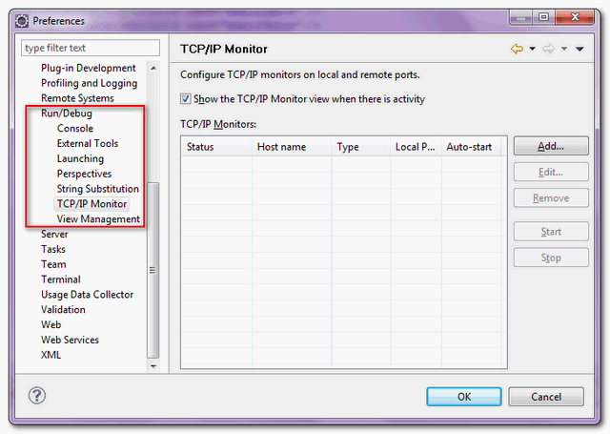
- Fill in server information, and choose type = “TCP/IP”

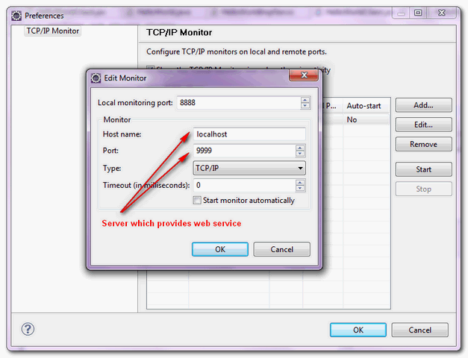
- Click on the “start” button to start tracing the web service traffic
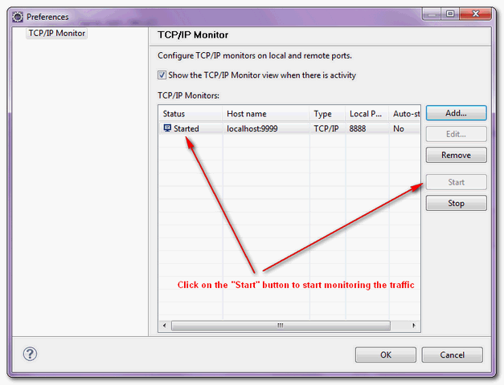
- Show the traced messaged in the “TCP/IP Monitor” view if any.
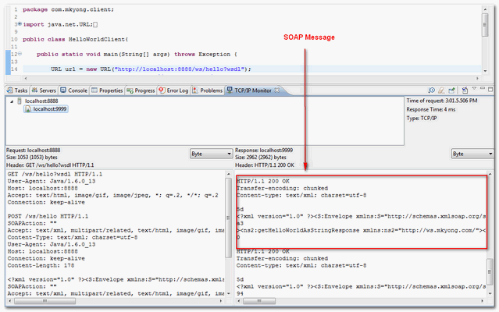

JAX-WS Handler

SOAP handler is a SOAP message interceptor, which is able to intercept incoming or outgoing SOAP message and manipulate its values. For example, attach a SOAP handler in client side, which will inject client’s computer MAC address into the SOAP header block for every outgoing SOAP message that is send by the client. In server side, attach another SOAP handler, to retrieve back the client’s MAC address in SOAP header block from every incoming SOAP message. So that the server side is able to determine which computer is allow to access the published service.
This article is split into 3 parts:
- JAX-WS : SOAP handler in server side.
- JAX-WS : SOAP handler in client side
- JAX-WS : SOAP handler testing for client and server side

JAX-WS : SOAP handler in server side

In this article, we show you how to create a SOAP handler and attach it in server side, to retrieve the mac address in SOAP header block from every incoming SOAP message. And do validation to allow only computer with MAC address “90-4C-E5-44-B9-8F” to access this published service. If an invalid client try to access the service, throw a SOAPFaultException back to the client.
Directory structure of this example
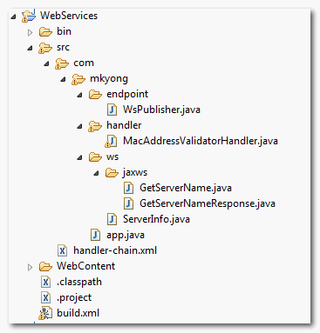

1. Web Service
A simple web service, with a getServerName() method to return a string.
File : ServerInfo.java
package com.mkyong.ws;

import javax.jws.HandlerChain;
import javax.jws.WebMethod;
import javax.jws.WebService;

@WebService
public class ServerInfo{

@WebMethod
public String getServerName() {

return "mkyong server";

}

}
Generate necessary Java files for the web service deployment.
D:\workspace-new\WebServices\bin>wsgen -keep -verbose -cp . com.mkyong.ws.ServerInfo
Note: ap round: 1
...
com\mkyong\ws\jaxws\GetServerName.java
com\mkyong\ws\jaxws\GetServerNameResponse.java
Note: ap round: 2
Two files are generated :
- com\mkyong\ws\jaxws\GetServerName.java
- com\mkyong\ws\jaxws\GetServerNameResponse.java
File : GetServerName.java
package com.mkyong.ws.jaxws;

import javax.xml.bind.annotation.XmlAccessType;
import javax.xml.bind.annotation.XmlAccessorType;
import javax.xml.bind.annotation.XmlRootElement;
import javax.xml.bind.annotation.XmlType;

@XmlRootElement(name = "getServerName", namespace = "http://ws.mkyong.com/")
@XmlAccessorType(XmlAccessType.FIELD)
@XmlType(name = "getServerName", namespace = "http://ws.mkyong.com/")
public class GetServerName {
}
File : GetServerNameResponse.java
package com.mkyong.ws.jaxws;

import javax.xml.bind.annotation.XmlAccessType;
import javax.xml.bind.annotation.XmlAccessorType;
import javax.xml.bind.annotation.XmlElement;
import javax.xml.bind.annotation.XmlRootElement;
import javax.xml.bind.annotation.XmlType;

@XmlRootElement(name = "getServerNameResponse", namespace = "http://ws.mkyong.com/")
@XmlAccessorType(XmlAccessType.FIELD)
@XmlType(name = "getServerNameResponse", namespace = "http://ws.mkyong.com/")
public class GetServerNameResponse {

@XmlElement(name = "return", namespace = "")
private String _return;

/**
*
* @return
* returns String
*/
public String getReturn() {
return this._return;
}

/**
*
* @param _return
* the value for the _return property
*/
public void setReturn(String _return) {
this._return = _return;
}

}

2. SOAP Handler
Create a SOAP handler to retrieve the value in SOAP header block, for every incoming SOAP message. See comments for the code explanation.
File MacAddressValidatorHandler.java
package com.mkyong.handler;

import java.io.IOException;
import java.util.Iterator;
import java.util.Set;
import javax.xml.namespace.QName;
import javax.xml.soap.Node;
import javax.xml.soap.SOAPBody;
import javax.xml.soap.SOAPConstants;
import javax.xml.soap.SOAPEnvelope;
import javax.xml.soap.SOAPException;
import javax.xml.soap.SOAPFault;
import javax.xml.soap.SOAPHeader;
import javax.xml.soap.SOAPMessage;
import javax.xml.ws.handler.MessageContext;
import javax.xml.ws.handler.soap.SOAPHandler;
import javax.xml.ws.handler.soap.SOAPMessageContext;
import javax.xml.ws.soap.SOAPFaultException;

public class MacAddressValidatorHandler implements SOAPHandler<SOAPMessageContext>{

@Override
public boolean handleMessage(SOAPMessageContext context) {

System.out.println("Server : handleMessage()......");

Boolean isRequest = (Boolean) context.get(MessageContext.MESSAGE_OUTBOUND_PROPERTY);

//for response message only, true for outbound messages, false for inbound
if(!isRequest){

try{
SOAPMessage soapMsg = context.getMessage();
SOAPEnvelope soapEnv = soapMsg.getSOAPPart().getEnvelope();
SOAPHeader soapHeader = soapEnv.getHeader();

//if no header, add one
if (soapHeader == null){
soapHeader = soapEnv.addHeader();
//throw exception
generateSOAPErrMessage(soapMsg, "No SOAP header.");
}

//Get client mac address from SOAP header
Iterator it = soapHeader.extractHeaderElements(SOAPConstants.URI_SOAP_ACTOR_NEXT);

//if no header block for next actor found? throw exception
if (it == null || !it.hasNext()){
generateSOAPErrMessage(soapMsg, "No header block for next actor.");
}

//if no mac address found? throw exception
Node macNode = (Node) it.next();
String macValue = (macNode == null) ? null : macNode.getValue();

if (macValue == null){
generateSOAPErrMessage(soapMsg, "No mac address in header block.");
}

//if mac address is not match, throw exceptionif(!macValue.equals("90-4C-E5-44-B9-8F")){
generateSOAPErrMessage(soapMsg, "Invalid mac address, access is denied.");
}

//tracking
soapMsg.writeTo(System.out);

}catch(SOAPException e){
System.err.println(e);
}catch(IOException e){
System.err.println(e);
}

}

//continue other handler chain
return true;
}

@Override
public boolean handleFault(SOAPMessageContext context) {

System.out.println("Server : handleFault()......");

return true;
}

@Override
public void close(MessageContext context) {
System.out.println("Server : close()......");
}

@Override
public Set<QName> getHeaders() {
System.out.println("Server : getHeaders()......");
return null;
}

private void generateSOAPErrMessage(SOAPMessage msg, String reason) {
try {
SOAPBody soapBody = msg.getSOAPPart().getEnvelope().getBody();
SOAPFault soapFault = soapBody.addFault();
soapFault.setFaultString(reason);
throw new SOAPFaultException(soapFault);
}
catch(SOAPException e) { }
}

}

3. SOAP Handler XML file
Create a SOAP handler XML file, and puts your SOAP handler declaration.
File: handler-chain.xml
<?xml version="1.0" encoding="UTF-8" standalone="yes"?>
<javaee:handler-chains
xmlns:javaee="http://java.sun.com/xml/ns/javaee"
xmlns:xsd="http://www.w3.org/2001/XMLSchema">
<javaee:handler-chain>
<javaee:handler>
<javaee:handler-class>com.mkyong.handler.MacAddressValidatorHandler</javaee:handler-class>
</javaee:handler>
</javaee:handler-chain>
</javaee:handler-chains>

4. Attach SOAP Handler –> Web Service
To attach above SOAP handler to web service ServerInfo.java, just annotate with @HandlerChain and specify the SOAP handler file name inside.
File : ServerInfo.java
package com.mkyong.ws;

import javax.jws.HandlerChain;
import javax.jws.WebMethod;
import javax.jws.WebService;

@WebService
@HandlerChain(file="handler-chain.xml")
public class ServerInfo{

@WebMethod
public String getServerName() {

return "mkyong server";

}

}

5. Web Service Publisher
A simple web service publisher for testing.
package com.mkyong.endpoint;

import javax.xml.ws.Endpoint;
import com.mkyong.ws.ServerInfo;

//Endpoint publisher
public class WsPublisher{

public static void main(String[] args) {
Endpoint.publish("http://localhost:8888/ws/server", new ServerInfo());

System.out.println("Service is published!");
}

}

JAX-WS: SOAP handler in client side

In this article, you will develop a web service client to access the published service in previous article, and attach a handler to inject client’s MAC address into header block, for every outgoing SOAP message that’s send by client side.
Directory structure of this example
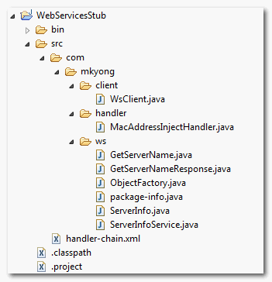

1. Web Service Client
Uses wsimport command to parse the published service WSDL file (http://localhost:8888/ws/server?wsdl) and generate all required files to access the service.
C:\>wsimport -keep -verbose http://localhost:8888/ws/server?wsdl
parsing WSDL...

generating code...
com\mkyong\ws\GetServerName.java
com\mkyong\ws\GetServerNameResponse.java
com\mkyong\ws\ObjectFactory.java
com\mkyong\ws\ServerInfo.java
com\mkyong\ws\ServerInfoService.java
com\mkyong\ws\package-info.java
Six files are generated automatically, you may only need to concern on the ServerInfoService.java.
File : ServerInfoService.java
@WebServiceClient(name = "ServerInfoService",
targetNamespace = "http://ws.mkyong.com/",
wsdlLocation = "http://localhost:8888/ws/server?wsdl")
public class ServerInfoService extends Service
{
//......
}
A client to access the published service.
File : WsClient.java
package com.mkyong.client;

import com.mkyong.ws.ServerInfo;
import com.mkyong.ws.ServerInfoService;

public class WsClient{

public static void main(String[] args) throws Exception {

ServerInfoService sis = new ServerInfoService();
ServerInfo si = sis.getServerInfoPort();

System.out.println(si.getServerName());

}

}

2. SOAP Handler
Create a SOAP handler to inject client’s MAC address into the SOAP header block, for every outgoing SOAP message. See comments for the code explanation.
File : MacAddressInjectHandler.java
package com.mkyong.handler;

import java.io.IOException;
import java.net.InetAddress;
import java.net.NetworkInterface;
import java.net.SocketException;
import java.net.UnknownHostException;
import java.util.Set;
import javax.xml.namespace.QName;
import javax.xml.soap.SOAPConstants;
import javax.xml.soap.SOAPEnvelope;
import javax.xml.soap.SOAPException;
import javax.xml.soap.SOAPHeader;
import javax.xml.soap.SOAPHeaderElement;
import javax.xml.soap.SOAPMessage;
import javax.xml.ws.handler.MessageContext;
import javax.xml.ws.handler.soap.SOAPHandler;
import javax.xml.ws.handler.soap.SOAPMessageContext;

public class MacAddressInjectHandler implements SOAPHandler<SOAPMessageContext>{

@Override
public boolean handleMessage(SOAPMessageContext context) {

System.out.println("Client : handleMessage()......");

Boolean isRequest = (Boolean) context.get(MessageContext.MESSAGE_OUTBOUND_PROPERTY);

//if this is a request, true for outbound messages, false for inbound
if(isRequest){

try{
SOAPMessage soapMsg = context.getMessage();
SOAPEnvelope soapEnv = soapMsg.getSOAPPart().getEnvelope();
SOAPHeader soapHeader = soapEnv.getHeader();

//if no header, add one
if (soapHeader == null){
soapHeader = soapEnv.addHeader();
}

//get mac address
String mac = getMACAddress();

//add a soap header, name as "mac address"
QName qname = new QName("http://ws.mkyong.com/", "macAddress");
SOAPHeaderElement soapHeaderElement = soapHeader.addHeaderElement(qname);

soapHeaderElement.setActor(SOAPConstants.URI_SOAP_ACTOR_NEXT);
soapHeaderElement.addTextNode(mac);
soapMsg.saveChanges();

//tracking
soapMsg.writeTo(System.out);

}catch(SOAPException e){
System.err.println(e);
}catch(IOException e){
System.err.println(e);
}

}

//continue other handler chain
return true;
}

@Override
public boolean handleFault(SOAPMessageContext context) {
System.out.println("Client : handleFault()......");
return true;
}

@Override
public void close(MessageContext context) {
System.out.println("Client : close()......");
}

@Override
public Set<QName> getHeaders() {
System.out.println("Client : getHeaders()......");
return null;
}

//return current client mac address
private String getMACAddress(){

InetAddress ip;
StringBuilder sb = new StringBuilder();

try {

ip = InetAddress.getLocalHost();
System.out.println("Current IP address : " + ip.getHostAddress());

NetworkInterface network = NetworkInterface.getByInetAddress(ip);

byte[] mac = network.getHardwareAddress();

System.out.print("Current MAC address : ");

for (int i = 0; i < mac.length; i++) {

sb.append(String.format("%02X%s", mac[i], (i < mac.length - 1) ? "-" : ""));

}
System.out.println(sb.toString());

} catch (UnknownHostException e) {

e.printStackTrace();

} catch (SocketException e){

e.printStackTrace();

}

return sb.toString();
}

}

3. SOAP Handler XML file
Create a SOAP handler XML file, and puts your SOAP handler declaration.
File : handler-chain.xml
<?xml version="1.0" encoding="UTF-8" standalone="yes"?>
<javaee:handler-chains
xmlns:javaee="http://java.sun.com/xml/ns/javaee"
xmlns:xsd="http://www.w3.org/2001/XMLSchema">
<javaee:handler-chain>
<javaee:handler>
<javaee:handler-class>com.mkyong.handler.MacAddressInjectHandler</javaee:handler-class>
</javaee:handler>
</javaee:handler-chain>
</javaee:handler-chains>

4. Attach SOAP Handler –> Web Service Client
To attach above SOAP handler to web service client, edit the ServerInfoService.java file (generated via wsimport), and annotate with @HandlerChain and specify the SOAP handler file name inside.
File : ServerInfoService.java
@WebServiceClient(name = "ServerInfoService",
targetNamespace = "http://ws.mkyong.com/",
wsdlLocation = "http://localhost:8888/ws/server?wsdl")
@HandlerChain(file="handler-chain.xml")
public class ServerInfoService extends Service
{
//......
}

JAX-WS : SOAP handler testing for client and server side

1. Valid MAC Address
From top to bottom showing a client with valid computer’s MAC address sending a request to published service.
Client : getHeaders()......
Client : getHeaders()......
Client : handleMessage()......
Current IP address : 192.168.0.2
Current MAC address : 90-4C-E5-44-B9-8F
<S:Envelope xmlns:S="http://schemas.xmlsoap.org/soap/envelope/">
<S:Header>
<macAddress xmlns="http://ws.mkyong.com/"
xmlns:SOAP-ENV="http://schemas.xmlsoap.org/soap/envelope/"
SOAP-ENV:actor="http://schemas.xmlsoap.org/soap/actor/next">
90-4C-E5-44-B9-8F
</macAddress>
</S:Header>
<S:Body>
<ns2:getServerName xmlns:ns2="http://ws.mkyong.com/"/>
</S:Body>
</S:Envelope>
Client : handleMessage()......
Client : close()......
mkyong server

2. Invalid MAC Address
From top to bottom showing a client with invalid computer’s MAC address sending a request to published service, and get a SOAPFaultException.
Client : getHeaders()......
Client : getHeaders()......
Client : handleMessage()......
Current IP address : 192.168.0.2
Current MAC address : 90-4C-E5-44-B9-00
<S:Envelope xmlns:S="http://schemas.xmlsoap.org/soap/envelope/">
<S:Header>
<macAddress xmlns="http://ws.mkyong.com/"
xmlns:SOAP-ENV="http://schemas.xmlsoap.org/soap/envelope/"
SOAP-ENV:actor="http://schemas.xmlsoap.org/soap/actor/next">
90-4C-E5-44-B9-00
</macAddress>
</S:Header>
<S:Body>
<ns2:getServerName xmlns:ns2="http://ws.mkyong.com/"/>
</S:Body>
</S:Envelope>
Server : handleMessage()......
Server : close()......
Client : handleFault()......
Client : close()......
Exception in thread "main" javax.xml.ws.soap.SOAPFaultException: Invalid mac address, access is denied.
at com.sun.xml.internal.ws.fault.SOAP11Fault.getProtocolException(Unknown Source)
at com.sun.xml.internal.ws.fault.SOAPFaultBuilder.createException(Unknown Source)
at com.sun.xml.internal.ws.client.sei.SyncMethodHandler.invoke(Unknown Source)
at com.sun.xml.internal.ws.client.sei.SyncMethodHandler.invoke(Unknown Source)
at com.sun.xml.internal.ws.client.sei.SEIStub.invoke(Unknown Source)
at $Proxy29.getServerName(Unknown Source)
at com.mkyong.client.WsClient.main(WsClient.java:13)
Caused by: javax.xml.ws.soap.SOAPFaultException: Invalid mac address, access is denied.
//...

Conclusion
In short, web service handler is just a interceptor to intercept incoming and outgoing SOAP message, both in client or server side, and it’s able to manipulate the SOAP message values as well.

JAX-WS Integration

JAX-WS + Java Web Application Integration Example

Often times, JAX-WS always be part of your Java web application. Here we show you how to integrate JAX-WS into Java web application easily.

1. Project Folder
First, review this project folder structure.
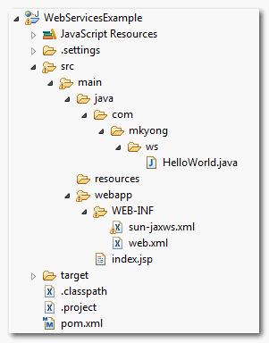

2. Web Service
A super simple web service. Code is self-explanatory.
File : HelloWorld.java
package com.mkyong.ws;

import javax.jws.WebMethod;
import javax.jws.WebService;

@WebService
public class HelloWorld{

@WebMethod(operationName="getHelloWorld")
public String getHelloWorld(String name) {
return "Hello World JAX-WS " + name;
}

}

3. Web Service Deployment Descriptor (sun-jaxws.xml)
Create a web service deployment descriptor, named sun-jaxws.xml.
File : sun-jaxws.xml
<?xml version="1.0" encoding="UTF-8"?>
<endpoints
xmlns="http://java.sun.com/xml/ns/jax-ws/ri/runtime"
version="2.0">
<endpoint
name="HelloWorldWs"
implementation="com.mkyong.ws.HelloWorld"
url-pattern="/hello"/>
</endpoints>

4. Web Application Deployment Descriptor (web.xml)
In the standard web.xml,
- Defines “com.sun.xml.ws.transport.http.servlet.WSServletContextListener” as listener class.
- Defines “com.sun.xml.ws.transport.http.servlet.WSServlet” as your web service (hello) servlet.
File : web.xml
<!DOCTYPE web-app PUBLIC
"-//Sun Microsystems, Inc.//DTD Web Application 2.3//EN"
"http://java.sun.com/dtd/web-app_2_3.dtd" >

<web-app>
<display-name>Archetype Created Web Application</display-name>

<listener>
<listener-class>
com.sun.xml.ws.transport.http.servlet.WSServletContextListener
</listener-class>
</listener>
<servlet>
<servlet-name>hello</servlet-name>
<servlet-class>
com.sun.xml.ws.transport.http.servlet.WSServlet
</servlet-class>
<load-on-startup>1</load-on-startup>
</servlet>
<servlet-mapping>
<servlet-name>hello</servlet-name>
<url-pattern>/hello</url-pattern>
</servlet-mapping>

</web-app>

5. Done
The integration between JAX-WS and web application is done. Deploy it and access via URL : http://localhost:8080/WebServicesExample/hello
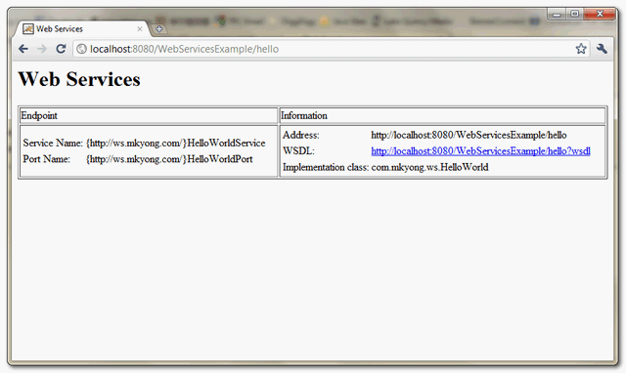

JAX-WS + Spring integration example

Here’s a guide to show you how to integrate Spring with JAX-WS, as mention in this link : http://jax-ws-commons.java.net/spring/. Upon finishing this tutorial, you will create a simple HelloWorld web service (JAX-WS), and DI a bean into the web service via Spring.

1. Project Folder
See the final project folder structure.
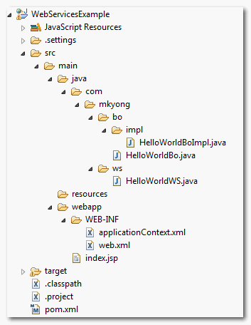

2. Project Dependencies
Use Maven to get all the library dependencies. The key to integrate Spring with JAX-WS is via jaxws-spring.jar.
File : pom.xml
<project xmlns="http://maven.apache.org/POM/4.0.0"
xmlns:xsi="http://www.w3.org/2001/XMLSchema-instance"
xsi:schemaLocation="http://maven.apache.org/POM/4.0.0
http://maven.apache.org/maven-v4_0_0.xsd">
<modelVersion>4.0.0</modelVersion>
<groupId>com.mkyong</groupId>
<artifactId>WebServicesExample</artifactId>
<packaging>war</packaging>
<version>1.0-SNAPSHOT</version>
<name>WebServicesExample Maven Webapp</name>
<url>http://maven.apache.org</url>

<repositories>
<repository>
<id>java.net</id>
<url>http://download.java.net/maven/2</url>
</repository>
</repositories>

<dependencies>

<dependency>
<groupId>junit</groupId>
<artifactId>junit</artifactId>
<version>3.8.1</version>
<scope>test</scope>
</dependency>

<!-- Spring framework -->
<dependency>
<groupId>org.springframework</groupId>
<artifactId>spring</artifactId>
<version>2.5.6</version>
</dependency>

<!-- JAX-WS -->
<dependency>
<groupId>com.sun.xml.ws</groupId>
<artifactId>jaxws-rt</artifactId>
<version>2.2.3</version>
</dependency>

<!-- Library from java.net, integrate Spring with JAX-WS -->
<dependency>
<groupId>org.jvnet.jax-ws-commons.spring</groupId>
<artifactId>jaxws-spring</artifactId>
<version>1.8</version>
<exclusions>
<exclusion>
<groupId>org.springframework</groupId>
<artifactId>spring-core</artifactId>
</exclusion>
<exclusion>
<groupId>org.springframework</groupId>
<artifactId>spring-context</artifactId>
</exclusion>
<exclusion>
<groupId>com.sun.xml.stream.buffer</groupId>
<artifactId>streambuffer</artifactId>
</exclusion>
<exclusion>
<groupId>org.jvnet.staxex</groupId>
<artifactId>stax-ex</artifactId>
</exclusion>
</exclusions>
</dependency>

</dependencies>
<build>
<finalName>web services</finalName>
<plugins>
<plugin>
<groupId>org.apache.maven.plugins</groupId>
<artifactId>maven-compiler-plugin</artifactId>
<version>2.3.1</version>
<configuration>
<source>1.6</source>
<target>1.6</target>
</configuration>
</plugin>
</plugins>
</build>
</project>
Note
The jaxws-spring’s pom.xml has a lot of unnecessary dependencies, you may need to exclude it via </exclusions> tag.

3. JAX-WS Hello World
A simple JAX-WS example, and dependency inject (DI) “HelloWorldBo” via Spring.
File : HelloWorldWS.java
package com.mkyong.ws;

import javax.jws.WebMethod;
import javax.jws.WebService;

import com.mkyong.bo.HelloWorldBo;

@WebService
public class HelloWorldWS{

//DI via Spring
HelloWorldBo helloWorldBo;

@WebMethod(exclude=true)
public void setHelloWorldBo(HelloWorldBo helloWorldBo) {
this.helloWorldBo = helloWorldBo;
}

@WebMethod(operationName="getHelloWorld")
public String getHelloWorld() {

return helloWorldBo.getHelloWorld();

}

}

4. Beans
Here’s the HelloWorldBo class, with a getHelloWorld() method to return a simple string.
File : HelloWorldBo.java
package com.mkyong.bo;

public interface HelloWorldBo{

String getHelloWorld();

}
File : HelloWorldBoImpl.java
package com.mkyong.bo.impl;

import com.mkyong.bo.HelloWorldBo;

public class HelloWorldBoImpl implements HelloWorldBo{

public String getHelloWorld(){
return "JAX-WS + Spring!";
}

}

5. Spring Beans Configuration
Spring beans configuration file to bind URL pattern “/hello” to “com.mkyong.ws.HelloWorldWS” web service class.
File : applicationContext.xml
<?xml version="1.0" encoding="UTF-8"?>
<beans xmlns="http://www.springframework.org/schema/beans"
xmlns:xsi="http://www.w3.org/2001/XMLSchema-instance"
xmlns:ws="http://jax-ws.dev.java.net/spring/core"
xmlns:wss="http://jax-ws.dev.java.net/spring/servlet"
xsi:schemaLocation="http://www.springframework.org/schema/beans
http://www.springframework.org/schema/beans/spring-beans-2.5.xsd
http://jax-ws.dev.java.net/spring/core
http://jax-ws.dev.java.net/spring/core.xsd
http://jax-ws.dev.java.net/spring/servlet
http://jax-ws.dev.java.net/spring/servlet.xsd"
>

<wss:binding url="/hello">
<wss:service>
<ws:service bean="#helloWs"/>
</wss:service>
</wss:binding>

<!-- Web service methods -->
<bean id="helloWs" class="com.mkyong.ws.HelloWorldWS">
<property name="helloWorldBo" ref="HelloWorldBo" />
</bean>

<bean id="HelloWorldBo" class="com.mkyong.bo.impl.HelloWorldBoImpl" />

</beans>
Note
With this jaxws-spring integration mechanism, the sun-jaxws.xml file is no longer required.

6. web.xml
In web.xml, declares “com.sun.xml.ws.transport.http.servlet.WSSpringServlet“, and link it to “/hello“.
<web-app id="WebApp_ID" version="2.4"
xmlns="http://java.sun.com/xml/ns/j2ee"
xmlns:xsi="http://www.w3.org/2001/XMLSchema-instance"
xsi:schemaLocation="http://java.sun.com/xml/ns/j2ee
http://java.sun.com/xml/ns/j2ee/web-app_2_4.xsd">

<display-name>Spring + JAX-WS</display-name>

<servlet>
<servlet-name>jaxws-servlet</servlet-name>
<servlet-class>
com.sun.xml.ws.transport.http.servlet.WSSpringServlet
</servlet-class>
</servlet>

<servlet-mapping>
<servlet-name>jaxws-servlet</servlet-name>
<url-pattern>/hello</url-pattern>
</servlet-mapping>

<!-- Register Spring Listener -->
<listener>
<listener-class>
org.springframework.web.context.ContextLoaderListener
</listener-class>
</listener>

</web-app>

7. Demo
Start the project, and access the deployed web service via URL “/hello“, for example http://localhost:8080/WebServicesExample/hello?wsdl
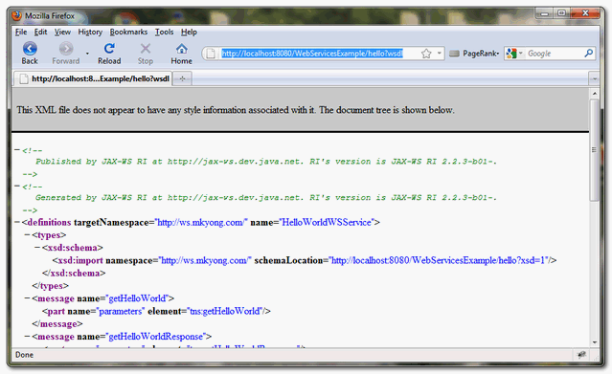

JAX-WS Security in Tomcat

Deploy JAX-WS web services on Tomcat + SSL connection
In this article, we show you how to deploy a JAX-WS web service on Tomcat with TLS / SSL or https secure connection enabled. Actually, the answer is quite simple, just deploys it as a normal web service and configured SSL connection on your Tomcat server properly :)
Note
This article is just a combination of my last few posts on developing web service in SSL connection environment.

1. Configure Tomcat + SSL
For detail, see this guide – Make Tomcat to support SSL or https connection.
Basically, just buy a certificate from trusted certificate provider, or use JDK’s keytool command to generate a dummy certificate for localhost testing. And put following portion into your Tomcat server.xml file.
File : $Tomcat\conf\server.xml
//...
<!-- Define a SSL HTTP/1.1 Connector on port 8443
This connector uses the JSSE configuration, when using APR, the
connector should be using the OpenSSL style configuration
described in the APR documentation -->

<Connector port="8443" protocol="HTTP/1.1" SSLEnabled="true"
maxThreads="150" scheme="https" secure="true"
clientAuth="false" sslProtocol="TLS"
keystoreFile="c:\your keystore file"
keystorePass="your keystore password" />
//...
Restart Tomcat, and now, your Tomcat is supported SSL connection, e.g https://localhost:8443

2. Deploy Web Service
Deploy it like a normal web service, see this guide – Deploy JAX-WS web services on Tomcat servlet container.

3. Test It
The configuration is done; you can access the deployed web service in SSL connection by using a normal web service client.
For example,
URL url = new URL("https://localhost:8443/HelloWorld/hello?wsdl");
QName qname = new QName("http://ws.mkyong.com/", "HelloWorldImplService");
Service service = Service.create(url, qname);

HelloWorld hello = service.getPort(HelloWorld.class);
System.out.println(hello.getHelloWorldAsString());
Note
For localhost SSL testing environment, the client will hit following exceptions, please read the problem and solution below:
- java.security.cert.CertificateException: No name matching localhost found
- SunCertPathBuilderException: unable to find valid certification path to requested target

4. Done
Your web service is in SSL protection, rather simple, no changes on the web service site; just configure your Tomcat to support SSL connection only.

Application Authentication with JAX-WS

One of the common way to handle authentication in JAX-WS is client provides “username” and “password”, attached it in SOAP request header and send to server, server parse the SOAP document and retrieve the provided “username” and “password” from request header and do validation from database, or whatever method prefer.
In this article, we show you how to implement the above “application level authentication in JAX-WS“.

Ideas…
On the web service client site, just put your “username” and “password” into request header.
Map<String, Object> req_ctx = ((BindingProvider)port).getRequestContext();
req_ctx.put(BindingProvider.ENDPOINT_ADDRESS_PROPERTY, WS_URL);

Map<String, List<String>> headers = new HashMap<String, List<String>>();
headers.put("Username", Collections.singletonList("mkyong"));
headers.put("Password", Collections.singletonList("password"));
req_ctx.put(MessageContext.HTTP_REQUEST_HEADERS, headers);
On the web service server site, get the request header parameters via WebServiceContext.
@Resource
WebServiceContext wsctx;

@Override
public String method() {

MessageContext mctx = wsctx.getMessageContext();

//get detail from request headers
Map http_headers = (Map) mctx.get(MessageContext.HTTP_REQUEST_HEADERS);
List userList = (List) http_headers.get("Username");
List passList = (List) http_headers.get("Password");

//...
That’s all, now, your deployed JAX-WS is supported application level authentication.

Authentication with JAX-WS Example
See a complete example.

1. WebService Server
Create a simple JAX-WS hello world example to handle the authentication in application level.
File : HelloWorld.java
package com.mkyong.ws;

import javax.jws.WebMethod;
import javax.jws.WebService;
import javax.jws.soap.SOAPBinding;
import javax.jws.soap.SOAPBinding.Style;

//Service Endpoint Interface
@WebService
@SOAPBinding(style = Style.RPC)
public interface HelloWorld{

@WebMethod String getHelloWorldAsString();

}
HelloWorldImpl.java
package com.mkyong.ws;

import java.util.List;
import java.util.Map;

import javax.annotation.Resource;
import javax.jws.WebService;
import javax.xml.ws.WebServiceContext;
import javax.xml.ws.handler.MessageContext;

//Service Implementation Bean
@WebService(endpointInterface = "com.mkyong.ws.HelloWorld")
public class HelloWorldImpl implements HelloWorld{

@Resource
WebServiceContext wsctx;

@Override
public String getHelloWorldAsString() {

MessageContext mctx = wsctx.getMessageContext();

//get detail from request headers
Map http_headers = (Map) mctx.get(MessageContext.HTTP_REQUEST_HEADERS);
List userList = (List) http_headers.get("Username");
List passList = (List) http_headers.get("Password");

String username = "";
String password = "";

if(userList!=null){
//get username
username = userList.get(0).toString();
}

if(passList!=null){
//get password
password = passList.get(0).toString();
}

//Should validate username and password with database
if (username.equals("mkyong") && password.equals("password")){
return "Hello World JAX-WS - Valid User!";
}else{
return "Unknown User!";
}

}
}

2. EndPoint Publisher
Create an endpoint publisher to deploy above web service at this URL : “http://localhost:9999/ws/hello”
File : HelloWorldPublisher.java
package com.mkyong.endpoint;

import javax.xml.ws.Endpoint;
import com.mkyong.ws.HelloWorldImpl;

//Endpoint publisher
public class HelloWorldPublisher{

public static void main(String[] args) {
Endpoint.publish("http://localhost:9999/ws/hello", new HelloWorldImpl());
}

}

3. WebService Client
Create a web service client to send “username” and “password” for authentication.
File : HelloWorldClient.java
package com.mkyong.client;

import java.net.URL;
import java.util.Collections;
import java.util.HashMap;
import java.util.List;
import java.util.Map;

import javax.xml.namespace.QName;
import javax.xml.ws.BindingProvider;
import javax.xml.ws.Service;
import javax.xml.ws.handler.MessageContext;

import com.mkyong.ws.HelloWorld;

public class HelloWorldClient{

private static final String WS_URL = "http://localhost:9999/ws/hello?wsdl";

public static void main(String[] args) throws Exception {

URL url = new URL(WS_URL);
QName qname = new QName("http://ws.mkyong.com/", "HelloWorldImplService");

Service service = Service.create(url, qname);
HelloWorld hello = service.getPort(HelloWorld.class);

/*******************UserName & Password ***************************/
Map<String, Object> req_ctx = ((BindingProvider)hello).getRequestContext();
req_ctx.put(BindingProvider.ENDPOINT_ADDRESS_PROPERTY, WS_URL);

Map<String, List<String>> headers = new HashMap<String, List<String>>();
headers.put("Username", Collections.singletonList("mkyong"));
headers.put("Password", Collections.singletonList("password"));
req_ctx.put(MessageContext.HTTP_REQUEST_HEADERS, headers);
/**********************************************************************/

System.out.println(hello.getHelloWorldAsString());

}
}
Output
Hello World JAX-WS - Valid User!

4. Tracing SOAP Traffic
From top to bottom, showing how SOAP envelope flows between client and server.
1. Client send request, the username “mkyong” and password “password” are included in the SOAP envelope.
POST /ws/hello?wsdl HTTP/1.1
Password: password
Username: mkyong
SOAPAction: ""
Accept: text/xml, multipart/related, text/html, image/gif, image/jpeg, *; q=.2, */*; q=.2
Content-Type: text/xml; charset=utf-8
User-Agent: Java/1.6.0_13
Host: localhost:8888
Connection: keep-alive
Content-Length: 178

<?xml version="1.0" ?>
<S:Envelope xmlns:S="http://schemas.xmlsoap.org/soap/envelope/">
<S:Body>
<ns2:getHelloWorldAsString xmlns:ns2="http://ws.mkyong.com/"/>
</S:Body>
</S:Envelope>
2. Server send back a normal response.
HTTP/1.1 200 OK
Transfer-encoding: chunked
Content-type: text/xml; charset=utf-8

<?xml version="1.0" ?>
<S:Envelope xmlns:S="http://schemas.xmlsoap.org/soap/envelope/">
<S:Body>
<ns2:getHelloWorldAsStringResponse xmlns:ns2="http://ws.mkyong.com/">
<return>Hello World JAX-WS - Valid User!</return>
</ns2:getHelloWorldAsStringResponse>
</S:Body>
</S:Envelope>
Done.

Container Authentication with JAX-WS – (Tomcat version)
In this article, we show you how to implement container authentication with JAX-WS, under Tomcat 6.0. In this way, the authentication is declarative rather than programmatic like this – application authentication in JAX-WS. And Tomcat implements the container authentication via security realm.
At the end of this article, the deployed web service will authenticate user based on the authentication data stored in Tomcat’s conf/tomcat-users.xml file.

1. WebService
Create a simple JAX-WS, RPC style.
File : UserProfile.java
package com.mkyong.ws;

import javax.jws.WebMethod;
import javax.jws.WebService;
import javax.jws.soap.SOAPBinding;
import javax.jws.soap.SOAPBinding.Style;

//Service Endpoint Interface
@WebService
@SOAPBinding(style = Style.RPC)
public interface UserProfile{

@WebMethod
String getUserName();

}
File : UserProfileImpl.java
package com.mkyong.ws;

import javax.jws.WebService;

//Service Implementation Bean
@WebService(endpointInterface = "com.mkyong.ws.UserProfile")
public class UserProfileImpl implements UserProfile{

@Override
public String getUserName() {

return "getUserName() : returned value";

}

}

2. web.xml
Configure a security role “operator”, make url “/user” required basic http authentication. See below web.xml file, self-explanatory.
File : web.xml
<?xml version="1.0" encoding="UTF-8"?>
<!DOCTYPE web-app PUBLIC "-//Sun Microsystems,
Inc.//DTD Web Application 2.3//EN"
"http://java.sun.com/dtd/web-app_2_3.dtd">

<web-app>
//...
<security-role>
<description>Normal operator user</description>
<role-name>operator</role-name>
</security-role>

<security-constraint>
<web-resource-collection>
<web-resource-name>Operator Roles Security</web-resource-name>
<url-pattern>/user</url-pattern>
</web-resource-collection>

<auth-constraint>
<role-name>operator</role-name>
</auth-constraint>

<user-data-constraint>
<transport-guarantee>NONE</transport-guarantee>
</user-data-constraint>
</security-constraint>

<login-config>
<auth-method>BASIC</auth-method>
</login-config>

<servlet-mapping>
<servlet-name>user</servlet-name>
<url-pattern>/user</url-pattern>
</servlet-mapping>
//...
</web-app>

Note
In production, it’s recommended to set the transport guarantee to “CONFIDENTIAL“, so that any access to resources via normal http request, such as http://localhost:8080/ws/user, Tomcat will redirect the request to https request https://localhost:8443/ws/user. Of course, the redirect https can be configure in The Tomcat’s conf/server.xml.
<user-data-constraint>
<transport-guarantee>CONFIDENTIAL</transport-guarantee>
</user-data-constraint>
See this article – Make Tomcat to support SSL or https connection

3. Tomcat Users
Add new role, username and password in $Tomcat/conf/tomcat-users.xml file. In this case, add new user “mkyong”,”123456″ and attached it to a role named “operator”.
File : $Tomcat/conf/tomcat-users.xml
<?xml version='1.0' encoding='utf-8'?>
<tomcat-users>
<role rolename="tomcat"/>
<role rolename="operator"/>
<user username="tomcat" password="tomcat" roles="tomcat"/>
<user username="mkyong" password="123456" roles="operator"/>
<user name="admin" password="admin" roles="admin,manager" />
</tomcat-users>

4. Tomcat Realm
Configure security realm in $Tomcat/conf/server.xml file. In this case, uses default UserDatabaseRealm to read the authentication information in $Tomcat/conf/tomcat-users.xml.
File : $Tomcat/conf/server.xml
<GlobalNamingResources>

<Resource name="UserDatabase" auth="Container"
type="org.apache.catalina.UserDatabase"
description="User database that can be updated and saved"
factory="org.apache.catalina.users.MemoryUserDatabaseFactory"
pathname="conf/tomcat-users.xml" />
</GlobalNamingResources>

<Realm className="org.apache.catalina.realm.UserDatabaseRealm"
resourceName="UserDatabase"/>

5. Deploy JAX-WS web service on Tomcat
See this detail guide on how to deploy JAX-WS web services on Tomcat.

6. Testing
Now, any access to your deployed web service is required username and password authentication, see figure :
URL : http://localhost:8080/WebServiceExample/user
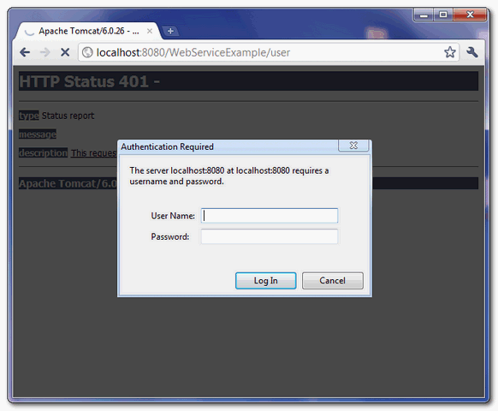

7. WebService Client
To access the deployed web service, bind a correct username and password like this :
UserProfile port = service.getPort(UserProfile.class);
BindingProvider bp = (BindingProvider) port;
bp.getRequestContext().put(BindingProvider.USERNAME_PROPERTY, "mkyong");
bp.getRequestContext().put(BindingProvider.PASSWORD_PROPERTY, "123456");
File : WsClient.java
package com.mkyong.client;

import java.net.URL;
import javax.xml.namespace.QName;
import javax.xml.ws.BindingProvider;
import javax.xml.ws.Service;

import com.mkyong.ws.UserProfile;

public class WsClient{

//can't parse wsdl "http://localhost:8080/WebServiceExample/user.wsdl" directly
//save it as local file, and parse it
private static final String WS_URL = "file:c://user.wsdl";

public static void main(String[] args) throws Exception {

URL url = new URL(WS_URL);
QName qname = new QName("http://ws.mkyong.com/", "UserProfileImplService");

Service service = Service.create(url, qname);
UserProfile port = service.getPort(UserProfile.class);

//add username and password for container authentication
BindingProvider bp = (BindingProvider) port;
bp.getRequestContext().put(BindingProvider.USERNAME_PROPERTY, "mkyong");
bp.getRequestContext().put(BindingProvider.PASSWORD_PROPERTY, "123456");

System.out.println(port.getUserName());

}

}
output
getUserName() : returned value
Note
For those clients provided an invalid username or password, Tomcat will return following exception :
Exception in thread "main" com.sun.xml.internal.ws.client.ClientTransportException:
request requires HTTP authentication: Unauthorized
Done.

How to configure Tomcat to support SSL or https
A guide to show you how to configure Tomcat 6.0 to support SSL or https connection.

1. Generate Keystore
First, uses “keytool” command to create a self-signed certificate. During the keystore creation process, you need to assign a password and fill in the certificate’s detail.
$Tomcat\bin>keytool -genkey -alias mkyong -keyalg RSA -keystore c:\mkyongkeystore
Enter keystore password:
Re-enter new password:
What is your first and last name?
[Unknown]: yong mook kim
What is the name of your organizational unit?
//omitted to save space
[no]: yes

Enter key password for <mkyong>
(RETURN if same as keystore password):
Re-enter new password:

$Tomcat\bin>
Here, you just created a certificate named “mkyongkeystore“, which locate at “c:\“.
Certificate Details
You can use same “keytool” command to list the existing certificate’s detail
$Tomcat\bin>keytool -list -keystore c:\mkyongkeystore
Enter keystore password:

Keystore type: JKS
Keystore provider: SUN

Your keystore contains 1 entry

mkyong, 14 Disember 2010, PrivateKeyEntry,
Certificate fingerprint (MD5): C8:DD:A1:AF:9F:55:A0:7F:6E:98:10:DE:8C:63:1B:A5

$Tomcat\bin>

2. Connector in server.xml
Next, locate your Tomcat’s server configuration file at $Tomcat\conf\server.xml, modify it by adding a connector element to support for SSL or https connection.
File : $Tomcat\conf\server.xml
//...
<!-- Define a SSL HTTP/1.1 Connector on port 8443
This connector uses the JSSE configuration, when using APR, the
connector should be using the OpenSSL style configuration
described in the APR documentation -->

<Connector port="8443" protocol="HTTP/1.1" SSLEnabled="true"
maxThreads="150" scheme="https" secure="true"
clientAuth="false" sslProtocol="TLS"
keystoreFile="c:\mkyongkeystore"
keystorePass="password" />
//...
Note
keystorePass="password" is the password you assigned to your keystore via “keytool” command.

3. Done
Saved it and restart Tomcat, access to https://localhost:8443/
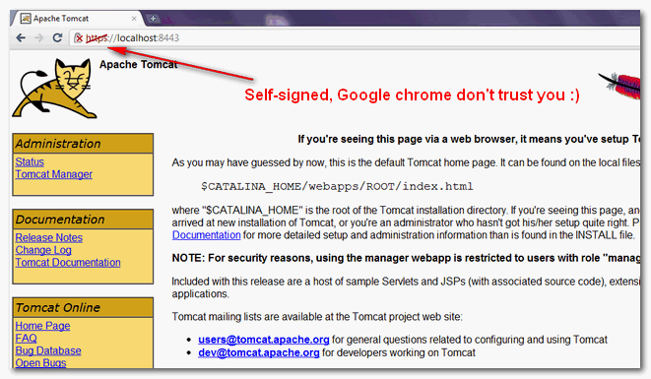
In this example, we are using Google Chrome to access the Tomcat configured SSL site, and you may notice a crossed icon appear before the https protocol :), this is caused by the self-signed certificate and Google chrome just do not trust it.
In production environment, you should consider buy a signed certificate from trusted SSL service provider like verisign or sign it with your own CA server

How to bypass certificate checking in a Java web service client

In Java web service development environment, developer are always generate a test certificate using keytool. While doing client testing, often times, the web service test client will hits following error messages :
- java.security.cert.CertificateException: No name matching localhost found
- SunCertPathBuilderException: unable to find valid certification path to requested target
Here’s a source code, that i copied from book : Java Web Services: Up and Running, 1st Edition by Martin Kalin, which is used to by pass all the certificate and hostname checking. A very useful code in testing environment ONLY, recommend to study and bookmark for future reference :)
Warning
Don’t try it at production environment, unless you have a very solid reason to by pass all the certificate checking. Ans if yes, why are you still using SSL connection? :)
package com.mkyong.client;

import java.net.MalformedURLException;
import java.net.URL;
import java.security.KeyManagementException;
import java.security.NoSuchAlgorithmException;
import java.security.SecureRandom;
import java.security.cert.Certificate;
import java.security.cert.X509Certificate;
import java.io.*;

import javax.net.ssl.HostnameVerifier;
import javax.net.ssl.HttpsURLConnection;
import javax.net.ssl.SSLContext;
import javax.net.ssl.SSLPeerUnverifiedException;
import javax.net.ssl.SSLSession;
import javax.net.ssl.TrustManager;
import javax.net.ssl.X509TrustManager;

public class HttpsClient{

public static void main(String[] args)
{
new HttpsClient().testIt();
}

private TrustManager[ ] get_trust_mgr() {
TrustManager[ ] certs = new TrustManager[ ] {
new X509TrustManager() {
public X509Certificate[ ] getAcceptedIssuers() { return null; }
public void checkClientTrusted(X509Certificate[ ] certs, String t) { }
public void checkServerTrusted(X509Certificate[ ] certs, String t) { }
}
};
return certs;
}

private void testIt(){
String https_url = "https://localhost:8443/HelloWorld/hello?wsdl";
URL url;
try {

// Create a context that doesn't check certificates.
SSLContext ssl_ctx = SSLContext.getInstance("TLS");
TrustManager[ ] trust_mgr = get_trust_mgr();
ssl_ctx.init(null, // key manager
trust_mgr, // trust manager
new SecureRandom()); // random number generator
HttpsURLConnection.setDefaultSSLSocketFactory(ssl_ctx.getSocketFactory());

url = new URL(https_url);
HttpsURLConnection con = (HttpsURLConnection)url.openConnection();

// Guard against "bad hostname" errors during handshake.
con.setHostnameVerifier(new HostnameVerifier() {
public boolean verify(String host, SSLSession sess) {
if (host.equals("localhost")) return true;
else return false;
}
});

//dumpl all cert info
print_https_cert(con);

//dump all the content
print_content(con);

} catch (MalformedURLException e) {
e.printStackTrace();
} catch (IOException e) {
e.printStackTrace();
}catch (NoSuchAlgorithmException e) {
e.printStackTrace();
}catch (KeyManagementException e) {
e.printStackTrace();
}
}

private void print_https_cert(HttpsURLConnection con){
if(con!=null){

try {

System.out.println("Response Code : " + con.getResponseCode());
System.out.println("Cipher Suite : " + con.getCipherSuite());
System.out.println("\n");

Certificate[] certs = con.getServerCertificates();
for(Certificate cert : certs){
System.out.println("Cert Type : " + cert.getType());
System.out.println("Cert Hash Code : " + cert.hashCode());System.out.println("Cert Public Key Algorithm : " + cert.getPublicKey().getAlgorithm());
System.out.println("Cert Public Key Format : " + cert.getPublicKey().getFormat());
System.out.println("\n");
}

} catch (SSLPeerUnverifiedException e) {
e.printStackTrace();
} catch (IOException e){
e.printStackTrace();
}
}
}

private void print_content(HttpsURLConnection con){
if(con!=null){

try {

System.out.println("****** Content of the URL ********");

BufferedReader br =
new BufferedReader(
new InputStreamReader(con.getInputStream()));

String input;

while ((input = br.readLine()) != null){
System.out.println(input);
}
br.close();

} catch (IOException e) {
e.printStackTrace();
}
}
}
}

java.security.cert.CertificateException: No name matching localhost found

Problem
Configured Tomcat to support SSL and deployed this simple hello world web service. And use following client connect to the deployed web service over SSL connection :
package com.mkyong.client;

import java.net.URL;
import javax.xml.namespace.QName;
import javax.xml.ws.Service;

import com.mkyong.ws.HelloWorld;

public class HelloWorldClient{

public static void main(String[] args) throws Exception {

URL url = new URL("https://localhost:8443/HelloWorld/hello?wsdl");
QName qname = new QName("http://ws.mkyong.com/", "HelloWorldImplService");

Service service = Service.create(url, qname);
HelloWorld hello = service.getPort(HelloWorld.class);
System.out.println(hello.getHelloWorldAsString());

}
}
It hits “No name matching localhost found” exception :
Caused by: javax.net.ssl.SSLHandshakeException:
java.security.cert.CertificateException: No name matching localhost found
at com.sun.net.ssl.internal.ssl.Alerts.getSSLException(Alerts.java:174)
at com.sun.net.ssl.internal.ssl.SSLSocketImpl.fatal(SSLSocketImpl.java:1611)
at com.sun.net.ssl.internal.ssl.Handshaker.fatalSE(Handshaker.java:187)
at com.sun.net.ssl.internal.ssl.Handshaker.fatalSE(Handshaker.java:181)
......
Caused by: java.security.cert.CertificateException: No name matching localhost found
at sun.security.util.HostnameChecker.matchDNS(HostnameChecker.java:210)
at sun.security.util.HostnameChecker.match(HostnameChecker.java:77)
......
Solution
This problem and solution is well explained in this article, you can use a Transport Security (SSL) Workaround for your “localhost” development environment.
To fix it, add a javax.net.ssl.HostnameVerifier() method to override the existing hostname verifier like this :
package com.mkyong.client;

import java.net.URL;
import javax.xml.namespace.QName;
import javax.xml.ws.Service;

import com.mkyong.ws.HelloWorld;

public class HelloWorldClient{

static {
//for localhost testing only
javax.net.ssl.HttpsURLConnection.setDefaultHostnameVerifier(
new javax.net.ssl.HostnameVerifier(){

public boolean verify(String hostname,
javax.net.ssl.SSLSession sslSession) {
if (hostname.equals("localhost")) {
return true;
}
return false;
}
});
}

public static void main(String[] args) throws Exception {

URL url = new URL("https://localhost:8443/HelloWorld/hello?wsdl");
QName qname = new QName("http://ws.mkyong.com/", "HelloWorldImplService");

Service service = Service.create(url, qname);
HelloWorld hello = service.getPort(HelloWorld.class);
System.out.println(hello.getHelloWorldAsString());

}
}
Output
Hello World JAX-WS
It’s working fine now.

Web services Handler Chains

Web Services and their clients may need to access the SOAP message for additional processing of the message request or response. You can create SOAP message handlers to enable Web Services and clients to perform this additional processing on the SOAP message. A SOAP message handler provides a mechanism for intercepting the SOAP message in both the request and response of the Web Service.
In order to use Handler chains in your Web service you have to add the @javax.jws.HandlerChain annotation at class level:
package com.sample.ws;

import javax.jws.HandlerChain;
import javax.jws.WebService;

@WebService(endpointInterface = "com.sample.ws.SampleWS", serviceName = "SampleWS")
@HandlerChain(file="/com/sample/ws/handler-chain.xml")
public class SampleWSImpl implements SampleWS {
public SampleWSImpl() {}
public String hello(String s) {
return "Hello "+s;
}
}

Ok, now your Web service will be proxied by one or more Handler defined in the handler-chain.xml configuration file.
In earlier releases of JBoss you had to place this file beneath the META-INF folder of your Web application. When using JBoss 7 just place it in the package folder which is included in the file property (In our example com/sample/ws).
Here is the handler-chain.xml which defines a Logging Handler:
<?xml version="1.0" encoding="UTF-8"?>
<handler-chains xmlns="http://java.sun.com/xml/ns/javaee">
<handler-chain>
<handler>
<handler-class>com.sample.LoggingHandler</handler-class>
</handler>
</handler-chain>
</handler-chains>

1. <handler-chains> is the root element that will contain a list of all handler chains that are defined for the Web Service.
2. The <handler-chain> child element of the <handler-chains> element lists all the handlers in the handler chain.
3. Within the <handler-chain> element is defined the <handler>, each handler element must in turn specify the name and also the fully qualified name of the Java class that implements the handler. If you have more than one handler, specify each one of them within the handler-chain element.

And this is the Handler Class:
package com.sample.handler;

import java.util.Set;

import javax.xml.namespace.QName;
import javax.xml.soap.SOAPMessage;
import javax.xml.ws.handler.MessageContext;
import javax.xml.ws.handler.soap.SOAPHandler;
import javax.xml.ws.handler.soap.SOAPMessageContext;

import org.apache.commons.io.output.ByteArrayOutputStream;

public class LoggingHandler implements SOAPHandler<SOAPMessageContext> {

@Override
public Set<QName> getHeaders() {
return null;
}

@Override
public void close(MessageContext context) {
}

@Override
public boolean handleFault(SOAPMessageContext context) {
logToSystemOut(context);
return true;
}

@Override
public boolean handleMessage(SOAPMessageContext context) {
logToSystemOut(context);
return true;
}

private void logToSystemOut(SOAPMessageContext smc) {

Boolean outboundProperty = (Boolean) smc.get(MessageContext.MESSAGE_OUTBOUND_PROPERTY);

try {
if (!outboundProperty.booleanValue()) {

SOAPMessage message = smc.getMessage();

System.out.println("Incoming message:");
ByteArrayOutputStream stream = new ByteArrayOutputStream();
message.writeTo(stream);

System.out.println(stream.toString());
System.out.println("=====================================");
}
}
catch (Exception e) {
System.out.println("Exception in handler: " + e);
}
}
}

The handleMessage() method is invoked for both incoming as well as outgoing messages
The above Handler will just print out all the SOAP incoming messages which are gathered as InputStream and finally converted to String using the ByteArrayOutputStream utility class from Apache Commons IO.
You can use SOAP message Handlers as well to improve the performance of your Web Service. After your Web Service has been deployed, you might discover that many consumers invoke it with the same parameters. You could improve the performance of your Web Service by caching the results of popular invokes of the Web Service (assuming the results are static) and immediately returning these results when appropriate, without ever invoking the back-end components that implement the Web Service. You implement this performance improvement by using handlers to check the request SOAP message to see if it contains the popular parameters.
Similarities between Handlers and CXF Interceptors
JAX-WS handlers are internally implemented in CXF by use of interceptors, so by definition anything that can be done with the former can be done with the latter. Handlers and interceptors are quite similar, in fact both have a handleMessage() which is defined by the top level interfaces. Both provide mechanisms for SOAP messages as well as more generic XML over HTTP routing. The routing direction is also similar in that handleFault(), when errors occur, causes the interceptors to run in reverse order.
Differences between Handlers and CXF Interceptors
The most important difference is that CXF Interceptors are split into two main categories: inbound and outgoing interceptors which are used to collect the server incoming message and the outgoing response. On the other hand when using JAX-WS handlers, the same handlers are activated both on request and reply. When using Handlers you can discriminate if it’s an inbound/outbound message by checking the MessageContext.MESSAGE_OUTBOUND_PROPERTY.
public boolean handleMessage(SOAPMessageContext messageContext)
{
Boolean outboundProperty = (Boolean)
messageContext.get (MessageContext.MESSAGE_OUTBOUND_PROPERTY);

if (outboundProperty.booleanValue()) {
System.out.println("\nOutbound message:");
} else {
System.out.println("\nInbound message:");
}

System.out.println("** Response: "+messageContext.getMessage().toString());
return true;
}

Another difference is that an additional close() method,used for object cleanup, is available with handlers but not interceptors.
public void close(MessageContext messageContext)
{
}

Another difference is how Fault exception are treated. When using Interceptors you can retrieve the Fault from the MessageContent:
public void handleMessage(SoapMessage message) throws Fault {
Fault fault = (Fault) message.getContent(Exception.class);
fault.setDetail(createDetailSomehow());
}

provided that you registered your Fault Interceptor:

@org.apache.cxf.interceptor.OutFaultInterceptors (interceptors = {"com.sample.CustomFaultInterceptor" })
@WebService(
public class SayHiImpl implements SayHi {
public long sayHi(long arg) {
return arg;
}

}

Apache CXF Interceptors

Interceptors are the fundamental processing unit which is native in Apache CXF. Basically they are Java classes that intercept your message to provide or apply certain core services to it. In this tutorial we will show how to use them and how to create some custom ones.
Apache CXF provides many built-in Interceptors that provide core services to the message that is being exchanged between consumer and service endpoint. These interceptors do the work of marshalling and unmarshalling, manipulating message headers, performing authorization checks, validating the message data, and so on.
You can also create your own Interceptors which are able to process incoming and outgoing messages. However before that, you need to learn how Interceptors work:
Interceptors are invoked in chain and organized in phases. When a CXF client invokes a CXF server, there is an outgoing interceptor chain for the client and an incoming chain for the server. When the server sends the response back to the client, there is an outgoing chain for the server and an incoming one for the client. Additionally, in the case of SOAPFaults, a CXF web service will create a separate outbound error handling chain and the client will create an inbound error handling chain.
InterceptorChains are divided up into Phases. The phase that each interceptor runs in is declared in the interceptor's constructor. Each phase may contain many interceptors. you'll have the following phases:

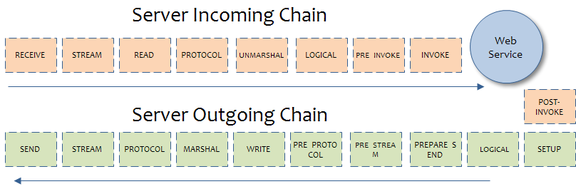
Writing an interceptor is relatively simple. Your interceptor needs to extend from either the AbstractPhaseInterceptor or one of its many subclasses such as AbstractSoapInterceptor.
public class MyPhaseInterceptor extends AbstractPhaseInterceptor {
public MyPhasedInterceptor() {
super(Phase.INVOKE); // Put this interceptor in this phase
}
public void handleMessage(Message msg) throws Fault {
// process the message
}
}

The most important thing you should notice is the constructor: it defines the phase name for your interceptor. When you specify the phase, your interceptor is ordered according to the phase in the chain.
Most of the time you will want to extend from sub-classes of AbstractPhaseInterceptor.
For example, using the SoapHeaderInterceptor you can access more specific information such as the SOAP Header.
For example the following Interceptor scans through the SOAP header:
package com.sample.ws;;

import java.util.List;

import org.apache.cxf.binding.soap.SoapMessage;
import org.apache.cxf.binding.soap.interceptor.AbstractSoapInterceptor;

import org.apache.cxf.headers.Header;
import org.apache.cxf.interceptor.Fault;
import org.apache.cxf.phase.Phase;

public class BasicAuthAuthorizationInterceptor extends
AbstractSoapInterceptor {

public BasicAuthAuthorizationInterceptor() {
super(Phase.INVOKE);
}
public void handleMessage(SoapMessage message) throws Fault {

List <Header> list = message.getHeaders();
for (Header header : list) {
System.out.println(header.getName() + " = " + header.toString());
}
}
}

You can also add information to the SOAP header using the message.getHeaders().add(header) method of the SoapMessage class.
package com.sample.ws;

import java.util.List;

import org.apache.cxf.binding.soap.SoapMessage;
import org.apache.cxf.binding.soap.interceptor.AbstractSoapInterceptor;

import org.apache.cxf.headers.Header;
import org.apache.cxf.interceptor.Fault;
import org.apache.cxf.phase.Phase;

public class BasicAuthAuthorizationInterceptor extends
AbstractSoapInterceptor {

public BasicAuthAuthorizationInterceptor() {
super(Phase.INVOKE);
}
public void handleMessage(SoapMessage message) throws Fault {

// . . . . . . . .
DocumentBuilder builder = null;
try {
builder = DocumentBuilderFactory.newInstance().newDocumentBuilder();
} catch (ParserConfigurationException e) {
e.printStackTrace();
}
Document doc = builder.newDocument();

Element eSecure = doc.createElement("Secured");

Element eUser = doc.createElement("user");
eUser.setTextContent("myuser");

Element ePassword = doc.createElement("password");
ePassword.setTextContent("password");

eSecure.appendChild(elementUser);
eSecure.appendChild(elementPassword);
// Create Header object
QName qnameCredentials = new QName("Secured");
Header header = new Header(qnameCredentials,
eSecure);
message.getHeaders().add(header);
}
}

In this example we have just added this header
<soap:Header>
<Secured>
<user>myuser</user>
<password>password</password>
</Secured>
</soap:Header>

Here's a custom Interceptor that extends AbstractLoggingInterceptor, providing a log of the SOAP Message which can be printed or stored somewhere if necessary:
package com.sample;

import java.io.InputStream;

import java.util.logging.Level;
import java.util.logging.Logger;

import org.apache.cxf.common.logging.LogUtils;
import org.apache.cxf.helpers.IOUtils;
import org.apache.cxf.interceptor.AbstractLoggingInterceptor;
import org.apache.cxf.interceptor.Fault;
import org.apache.cxf.interceptor.LoggingMessage;
import org.apache.cxf.io.CachedOutputStream;
import org.apache.cxf.message.Message;
import org.apache.cxf.phase.Phase;

/**
* A simple logging handler which outputs the bytes of the message to the
* Logger.
*/

public class LogInterceptor extends AbstractLoggingInterceptor {
private static final Logger LOG = LogUtils.getLogger(LogInterceptor.class);

public LogInterceptor() {
super(Phase.RECEIVE);
}

public void handleMessage(Message message) throws Fault {

if (writer != null || getLogger().isLoggable(Level.INFO)) {
logging(message);
}
}

protected void logging(Message message) throws Fault {

if (message.containsKey(LoggingMessage.ID_KEY)) {
return;
}
String id = (String)message.getExchange().get(LoggingMessage.ID_KEY);
if (id == null) {
id = LoggingMessage.nextId();
message.getExchange().put(LoggingMessage.ID_KEY, id);
}
message.put(LoggingMessage.ID_KEY, id);
final LoggingMessage buffer = new LoggingMessage("Inbound Message\n----------------------------", id);

Integer responseCode = (Integer)message.get(Message.RESPONSE_CODE);
if (responseCode != null) {
buffer.getResponseCode().append(responseCode);
}

String encoding = (String)message.get(Message.ENCODING);

if (encoding != null) {
buffer.getEncoding().append(encoding);
}
String httpMethod = (String)message.get(Message.HTTP_REQUEST_METHOD);
if (httpMethod != null) {
buffer.getHttpMethod().append(httpMethod);
}
String ct = (String)message.get(Message.CONTENT_TYPE);
if (ct != null) {
buffer.getContentType().append(ct);
}
Object headers = message.get(Message.PROTOCOL_HEADERS);

if (headers != null) {
buffer.getHeader().append(headers);
}
String uri = (String)message.get(Message.REQUEST_URL);
if (uri != null) {
buffer.getAddress().append(uri);
String query = (String)message.get(Message.QUERY_STRING);
if (query != null) {
buffer.getAddress().append("?").append(query);
}
}

InputStream is = message.getContent(InputStream.class);
if (is != null) {
CachedOutputStream bos = new CachedOutputStream();
try {
IOUtils.copy(is, bos);

bos.flush();
is.close();

message.setContent(InputStream.class, bos.getInputStream());

writePayload(buffer.getPayload(), bos, encoding, ct);

bos.close();
} catch (Exception e) { throw new Fault(e); }
}
System.out.println("============= SOAP Message ==============");
System.out.println(buffer.toString());
}

@Override
protected Logger getLogger() {
return LOG;
}
}

Adding Interceptors to your Web services

Interceptors can be added either via configuration, via annotations or even programmatically. The simplest of all is maybe using annoations. The following example uses two custom interceptors Test1Interceptor which is bound to the Server Incoming Chain and Test2Interceptor which is bound to the Outgoing Chain:
@org.apache.cxf.interceptor.InInterceptors (interceptors = {"com.example.Test1Interceptor" })
@org.apache.cxf.interceptor.OutInterceptors (interceptors = {"com.example.Test2Interceptor" })
})
@WebService(
public class SayHiImpl implements SayHi {
public long sayHi(long arg) {
return arg;
}

}

and here's how you can configure these interceptors using cxf.xml configuration file
<beans xmlns="http://www.springframework.org/schema/beans"
xmlns:xsi="http://www.w3.org/2001/XMLSchema-instance"
xmlns:cxf="http://cxf.apache.org/core"
xsi:schemaLocation="
http://www.springframework.org/schema/beans http://www.springframework.org/schema/beans/spring-beans.xsd
http://cxf.apache.org/core http://cxf.apache.org/schemas/core.xsd">

<bean id="MyInterceptor1" class="com.example.Test1Interceptor"/>
<bean id="MyInterceptor2" class="com.example.Test2Interceptor"/>

<cxf:bus>
<cxf:inInterceptors>
<ref bean="MyInterceptor1"/>
</cxf:inInterceptors>
<cxf:outInterceptors>
<ref bean="MyInterceptor2"/>
</cxf:outInterceptors>
</cxf:bus>
</beans>

Adding Fault Interceptors to your Web services

In the case of SOAPFaults, a CXF web service will create a separate outbound error handling chain and the client will create an inbound error handling chain. By default, the last interceptor in the outbound fault chain is Soap11FaultOutInterceptor which automatically appends the details of the SOAPFault into the response. This might now be always desirable as we might want to display a custom error message.
In order to do that you need simply to add a custom OutFaultInterceptors which modifies the details of the SOAPFault. There are many places that we could do this, for example you could do that before the final interceptor (Soap11FaultOutInterceptor) is called.
public class CustomFaultInterceptor extends AbstractSoapInterceptor {

public CustomFaultInterceptor() {
super(Phase.MARSHAL);
}

public void handleMessage(SoapMessage message) throws Fault {
Fault fault = (Fault) message.getContent(Exception.class);
fault.setDetail(createDetailSomehow());
}

}

And here's how you can bind this Interceptor to your Web service using annotations:
@org.apache.cxf.interceptor.OutFaultInterceptors (interceptors = {"com.sample.CustomFaultInterceptor" })
@WebService(
public class SayHiImpl implements SayHi {
public long sayHi(long arg) {
return arg;
}

}

CXF contributed interceptors

Default JAX-WS Incoming interceptor chain (Server):
- AttachmentInInterceptor Parse the mime headers for mime boundaries, finds the "root" part and resets the input stream to it, and stores the other parts in a collection of Attachments
- StaxInInterceptor Creates an XMLStreamReader from the transport InputStream on the Message
- ReadHeadersInterceptor Parses the SOAP headers and stores them on the Message
- SoapActionInInterceptor Parses "soapaction" header and looks up the operation if a unique operation can be found for that action.
- MustUnderstandInterceptor Checks the MustUnderstand headers, its applicability and process it, if required
- SOAPHandlerInterceptor SOAP Handler as per JAX-WS
- LogicalHandlerInInterceptor Logical Handler as per JAX-WS
- CheckFaultInterceptor Checks for fault, if present aborts interceptor chain and invokes fault handler chain
- URIMappingInterceptor Can handle HTTP GET, extracts operation info and sets the same in the Message
- DocLiteralnInterceptor Examines the first element in the SOAP body to determine the appropriate Operation (if soapAction did not find one) and calls the Databinding to read in the data.
- SoapHeaderInterceptor Perform databinding of the SOAP headers for headers that are mapped to parameters
- WrapperClassInInterceptor For wrapped doc/lit, the DocLiteralInInterceptor probably read in a single JAXB bean. This interceptor pulls the individual parts out of that bean to construct the Object[] needed to invoke the service.
- SwAInInterceptor For Soap w/ Attachments, finds the appropriate attachments and assigns them to the correct spot in the parameter list.
- HolderInInterceptor For OUT and IN/OUT parameters, JAX-WS needs to create Holder objects. This interceptor creates the Holders and puts them in the parameter list.
- ServiceInvokerInInterceptor Actually invokes the service.

Default Outgoing chain stack (Server):
- HolderOutInterceptor For OUT and IN/OUT params, pulls the values out of the JAX-WS Holder objects (created in HolderInInterceptor) and adds them to the param list for the out message.
- SwAOutInterceptor For OUT parts that are Soap attachments, pulls them from the list and holds them for later.
- WrapperClassOutInterceptor For doc/lit wrapped, takes the remaining parts and creates a wrapper JAXB bean to represent the whole message.
- SoapHeaderOutFilterInterceptor Removes inbound marked headers
- SoapActionOutInterceptor Sets the SOAP Action
- MessageSenderInterceptor Calls back to the Destination object to have it setup the output streams, headers, etc... to prepare the outgoing transport.
- SoapPreProtocolOutInterceptor This interceptor is responsible for setting up the SOAP version and header, so that this is available to any pre-protocol interceptors that require these to be available.
- AttachmentOutInterceptor If this service uses attachments (either SwA or if MTOM is enabled), it sets up the Attachment marshallers and the mime stuff that is needed.
- StaxOutInterceptor Creates an XMLStreamWriter from the OutputStream on the Message.
- SoapHandlerInterceptor JAX-WS SOAPHandler
- SoapOutInterceptor Writes start element for soap:envelope and complete elements for other header blocks in the message. Adds start element for soap:body too.
- LogicalHandlerOutInterceptor JAX-WS Logical handler stuff
- WrapperOutInterceptor If wrapped doc/lit and not using a wrapper bean or if RPC lit, outputs the wrapper element to the stream.
- BareOutInterceptor Uses the databinding to write the params out.
- SoapOutInterceptor$SoapOutEndingInterceptor Closes the soap:body and soap:envelope
- StaxOutInterceptor$StaxOutEndingInterceptor Flushes the stax stream.
- MessageSenderInt$MessageSenderEnding Closes the exchange, lets the transport know everything is done and should be flushed to the client.

